Enhancement request – make linked element planned end date visible.
It would be helpful to be able to see the due date, planned end date or end date when adding a link to an element, as this would show if the issue, task, action was planned to finish before the element needs to be finished. I not concerned if this means removing the creation date.
Currently visible Creation date
Add Action planned end date or
Activity (task) end date
ISSUES

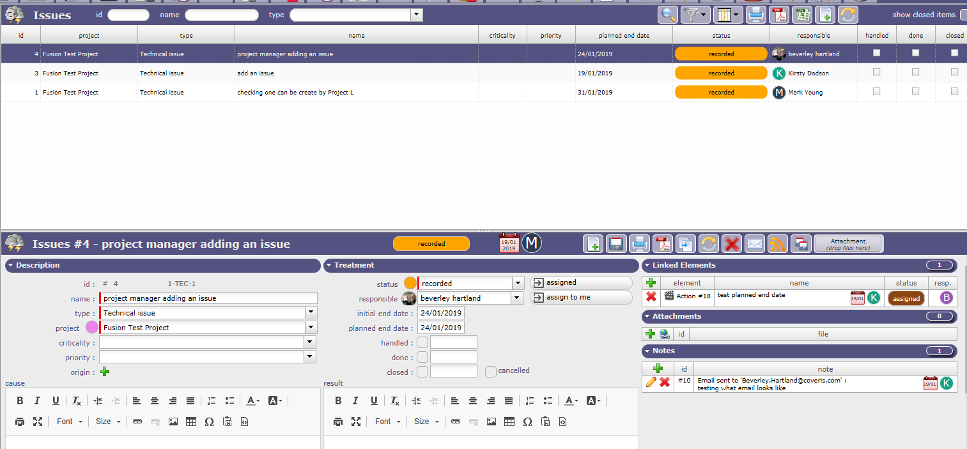
Plus when you try to add a linked element, you have to scroll through all those of type, it would be good to have a search feature as it will be difficult to find elements (actions when there are several 100s in the project). (Search for not closed, raised by +/or responsible by +/or part of name “phase” e.g review to return review all instruction documents)
Or/+ to be able to add an new element e.g action when in issue creation, that is linked to the issue.

ACTIONS
Currently visible Creation date
Add Action planned end date or
Activity (task) end date

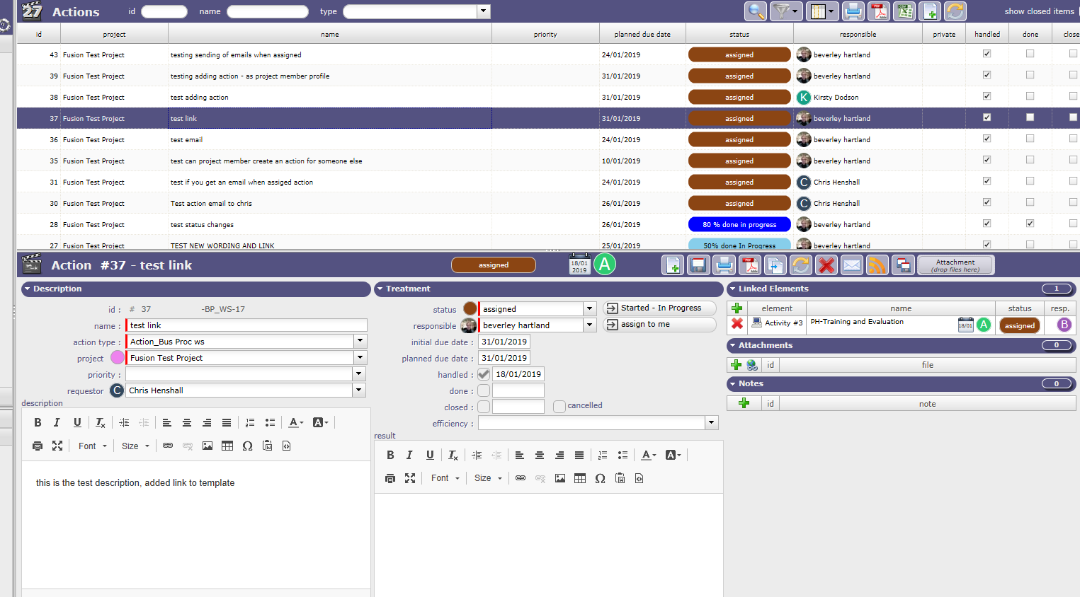

Plus when you try to add a linked element, you have to scroll through all those of type, it would be good to have a search feature as it will be difficult to find elements (actions when there are several 100s in the project). (Search for not closed, raised by +/or responsible by +/or part of name “phase” e.g review to return review all instruction documents)
Or/+ to be able to add an new element e.g action when in issue creation, that is linked to the issue.

Currently visible Creation date
Add Action planned end date or
Activity (task) end date
ACTIVITY
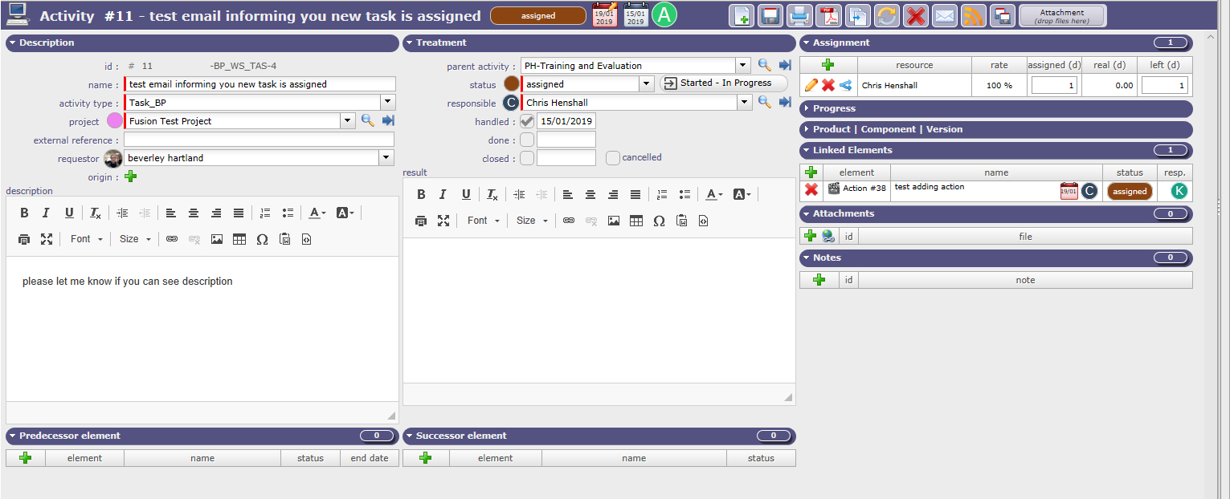

Plus when you try to add a linked element, you have to scroll through all those of type, it would be good to have a search feature as it will be difficult to find elements (actions when there are several 100s in the project). (Search for not closed, raised by +/or responsible by +/or part of name “phase” e.g review to return review all instruction documents)
Or/+ to be able to add an new element e.g action when in issue creation, that is linked to the issue.

