Can not change status of test session #5 to closed.

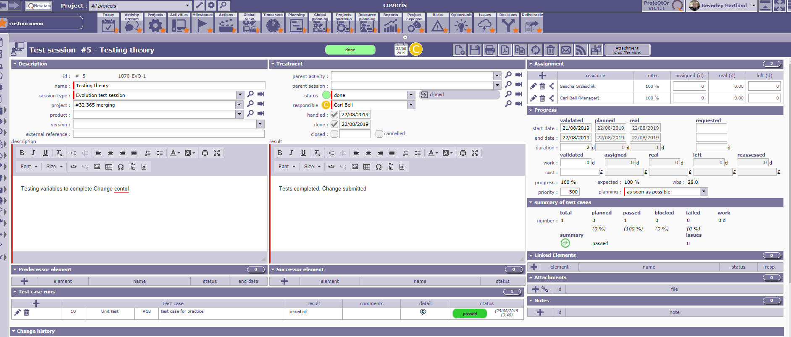

If you try to change status to closed, it trys to come up with an error message, and eventually indicates projeqtor session is disconnected.

