Can not view different base lines saved of projects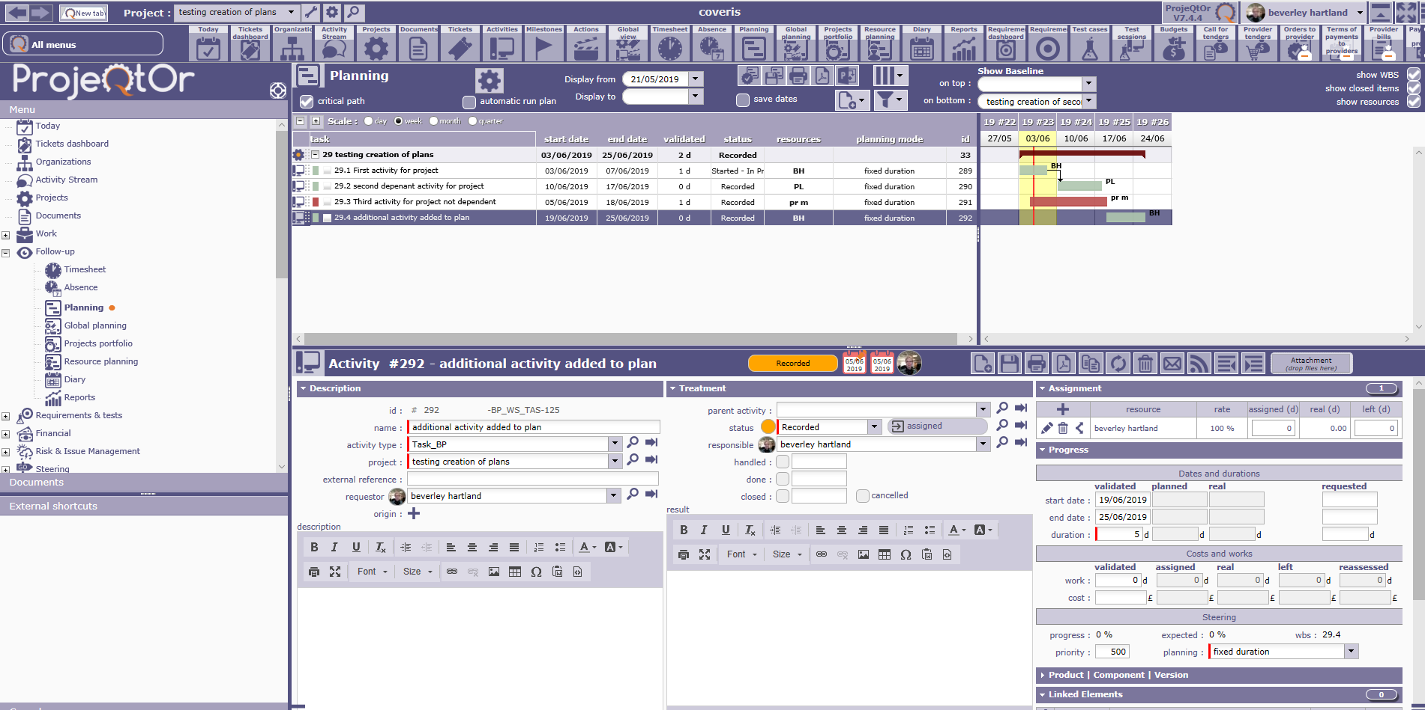

I successfully managed to save a version of a simple plan.
I have tried with having this and a slightly changed saved version of plan in the base line fields. But I can not see both versions or the change highlights or anything?

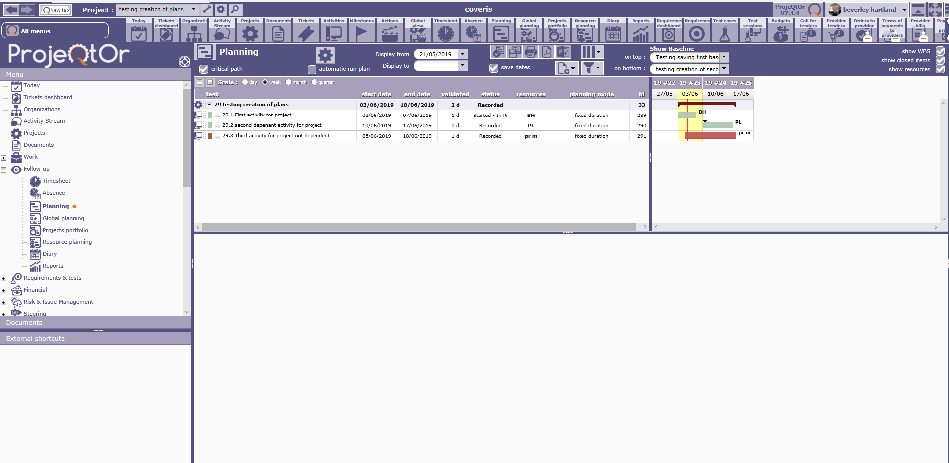

I have also tried having just having on bottom, saved file and changing the displayed plan to see what occurs, again, can not see old saved plan?? What is supposed to happen, how should this feature be used?

