PROBLEM WITH RECORDING CALCULATION OF PLANNED DATES WHICH TIME SHEET ENTRIES AND REPLANNING. Getting random planned start dates.

Recording time less than required time.
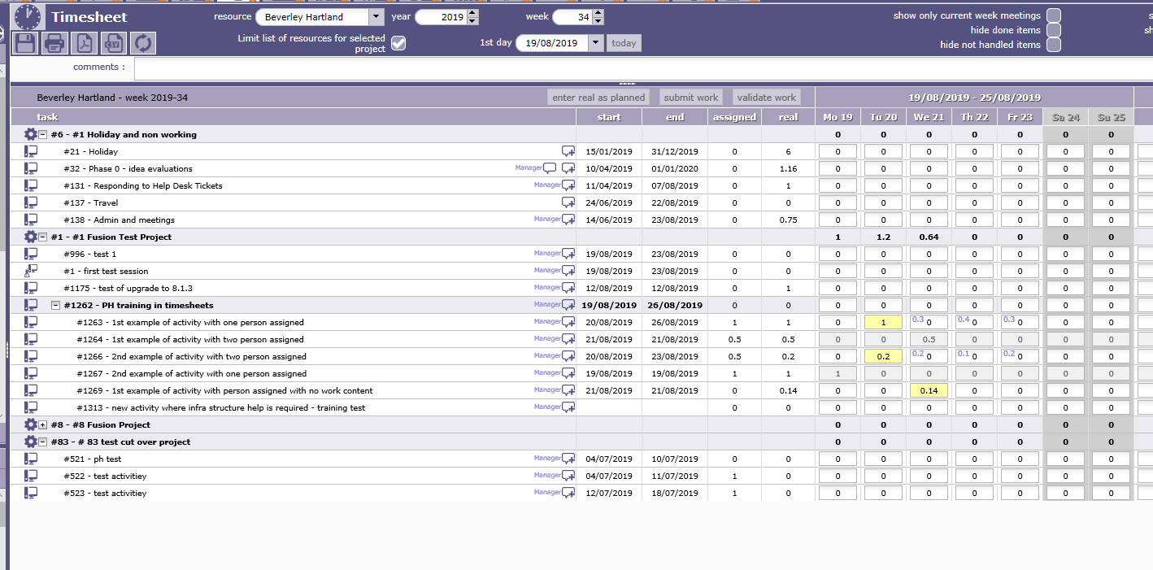

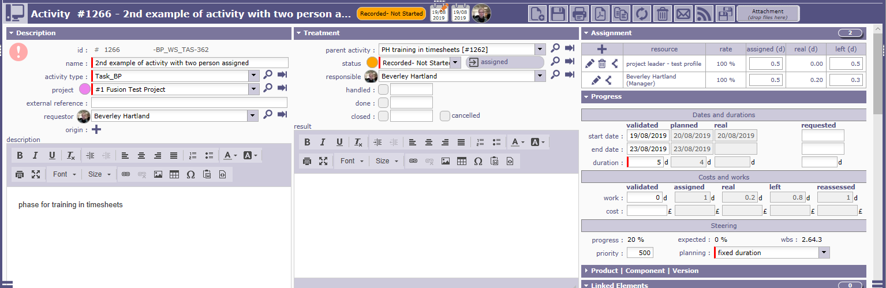

ACTUAL TIME SHEET RECORDING EARLIER THAN PLAN < ASSIGNED TIME. PLANNED START DATE = ACTUAL DATE, PLANNED END DATE UNCHANGED
Which is what I expected
I then needed to add a new activity to the plan.

So I added one. Then need to re-run planning to get it to calculate planned dates for this new activity. I selected the start date of the project to run the project re-plan from as I did not want other planned dates to change for other activities.
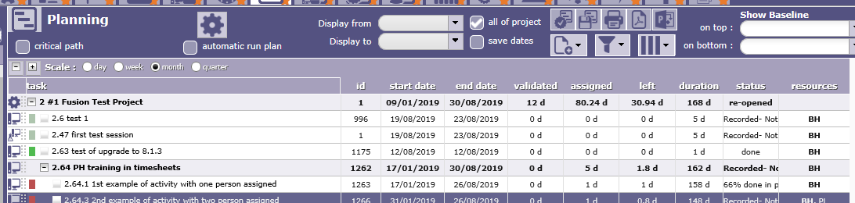
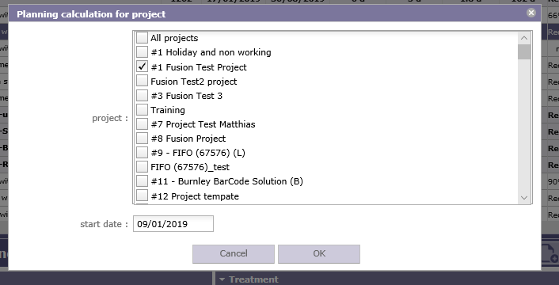
It then changed the planned start date to a random date do idea why it has chosen 31st January. Plus an end date of 26th August which could be 5 days from the first recorded time sheet entry on 20th August.
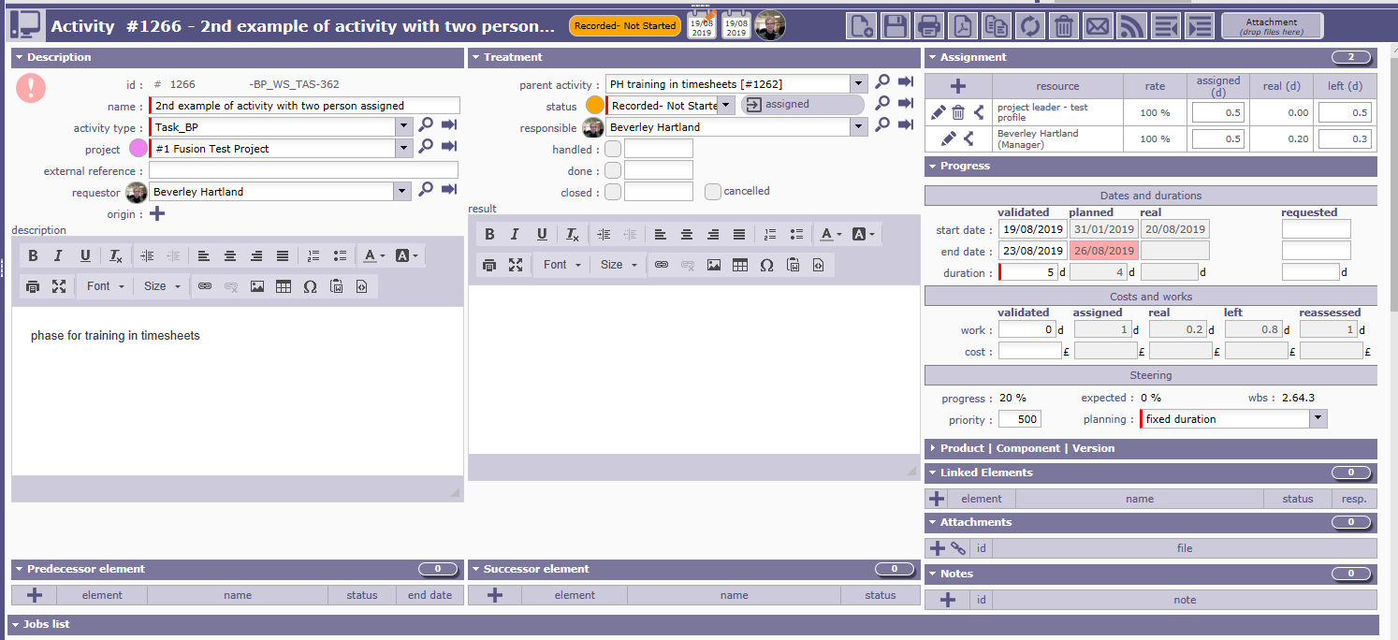

The new activity did create dates as I expected.
Where no work assigned but people
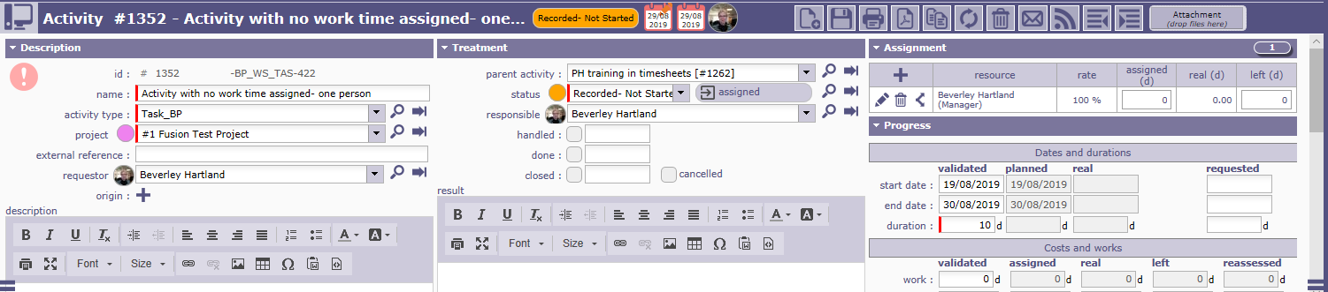

I tried replanning using the 19th August as the start date, but this made no difference to activity #1266 which kept the start planned date of 31st January!

