Another example of problem with last change not working in email generated from templates

HI
I have tried this so far to get this working with an ACTION, ISSUE, RISK, OPPORTUNITY (not tested it with other elements ) with no luck. PS. Getting same issue with LINKs as I reported with other elements , only getting one of linked elements printing on email not all.

However, here is an example for Opportunity
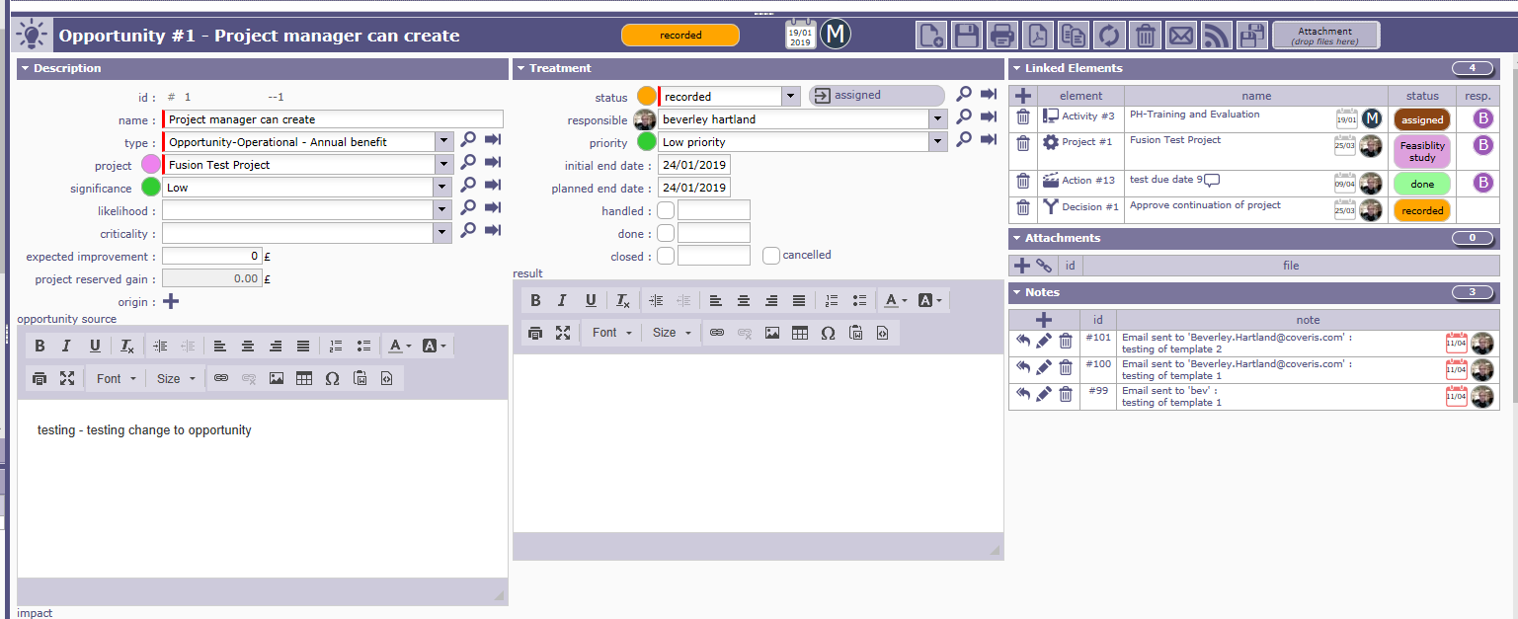

However the email template did not print any history of updates.
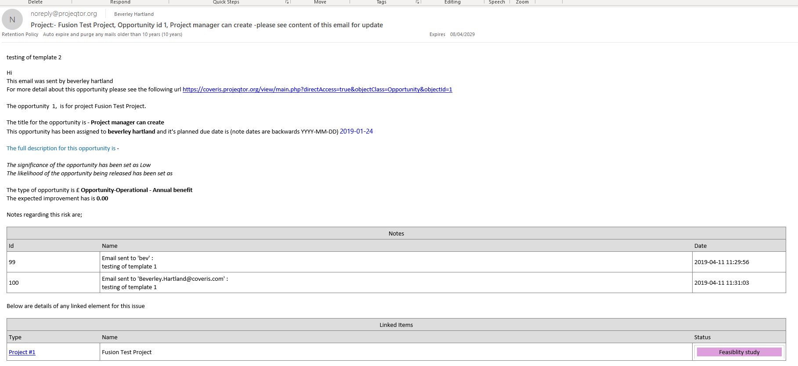

The email template used was

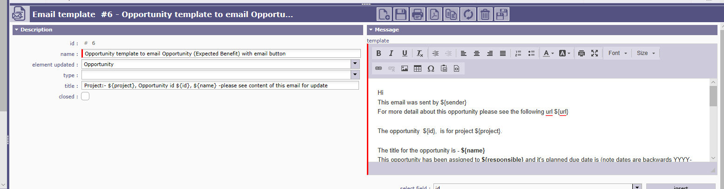
Hi
This email was sent by ${sender}
For more detail about this opportunity please see the following url ${url}

The opportunity ${id}, is for project ${project}.

The title for the opportunity is - ${name}
This opportunity has been assigned to ${responsible} and it's planned due date is (note dates are backwards YYYY-MM-DD) ${actualEndDate}

The full description for this opportunity is ${description}

The significance of the opportunity has been set as ${nameSeverity}
The likelihood of the opportunity being released has been set as ${nameLikelihood}

The type of opportunity is £ ${nameOpportunityType}
The expected improvement has is ${impactCost}

Notes regarding this risk are;

${NOTE}

Below are details of any linked element for this issue

${LINK}

${HISTORY}

Thanks Bev

