Problem with planned end dates and time sheets
How to get meaningful planned end dates, when an activity takes longer than original planned in work assigned time? Time sheets only show planned dates. Do you have a suggestion as to how we can get this to work.
If a person is assigned to an activity. It appears in their time sheet, planning has to be run for the range of dates when activity is required to appear. We do not always know what the work time might be. 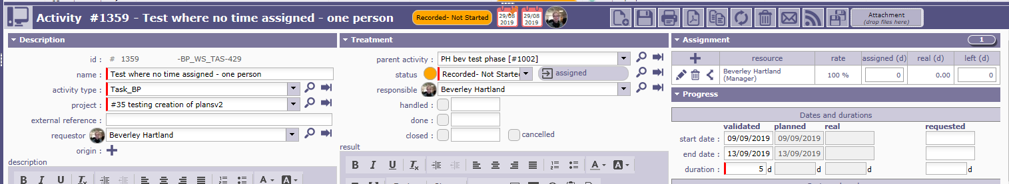
I ran planning for a start date of the project start on 24th June. This calculated as expected a planned start date of 9th Sept and end date of 13th Sept, which originally appeared in the timesheet. I then recorded and saved the actual time taken to start the activity. This updated the time sheet to the date recorded 2nd September and planned start and end dates being 2nd Sept.
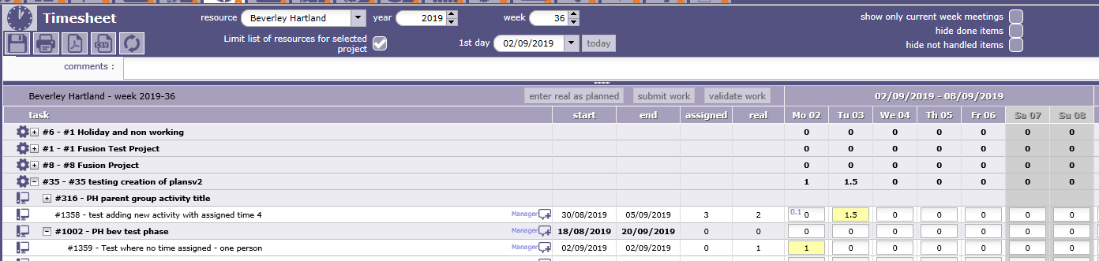
For this activity I then recorded I had done a days work on 2nd Sept. It updated as per above.
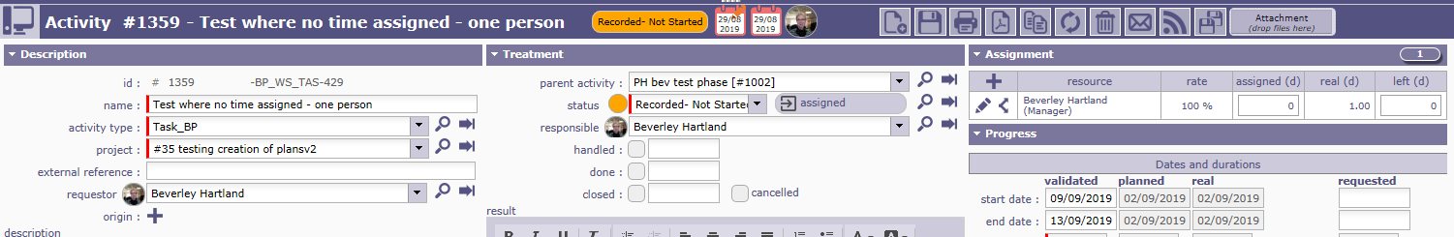
I then wanted to indicate I had not finished the activity, so I increased the assigned time and ensured there was some left time in assignments.
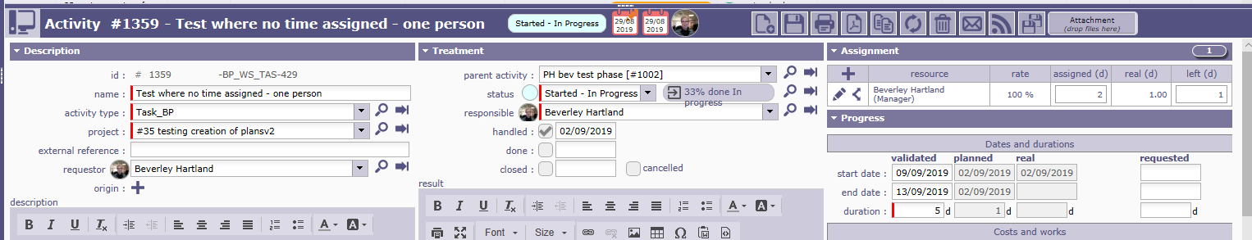
This made no difference to planned dates, The planned dates did not change and stayed as 2nd September. I would have expected the planned end date to to be the original planned end date as this is greater than current actual recorded dates for this activity? If I was to run planning again the project lots of activities would update and move about? It seems to change the planned start dates to random dates where no dependencies exist. (see separate issue logged. Plus we would not wish to give team members the power to do run planning calculation and potentially change the plan.. We only want project managers to do this so they can keep control of their projects.)

SECOND TEST.
Were some time was assigned for the activity but it takes longer than expected. In this case 1 days assigned work was planned.
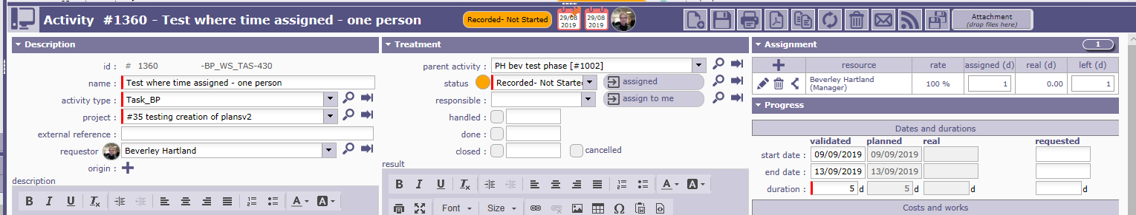
The time sheet showed
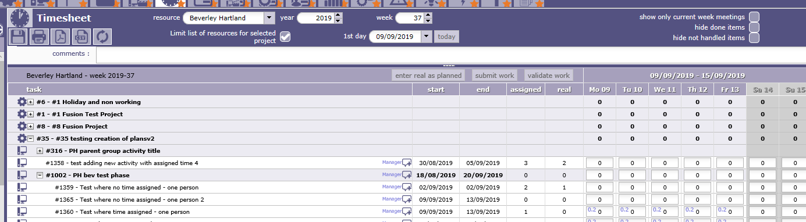
I then recorded actual time used for activity on Tuesday 10th Sept, using the time sheet.
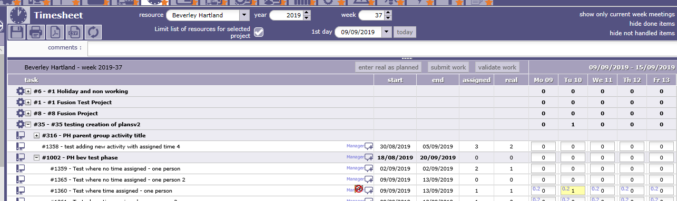

I then checked the activity #1360 and as expected the planned start and end date had updated to 10th Sept.

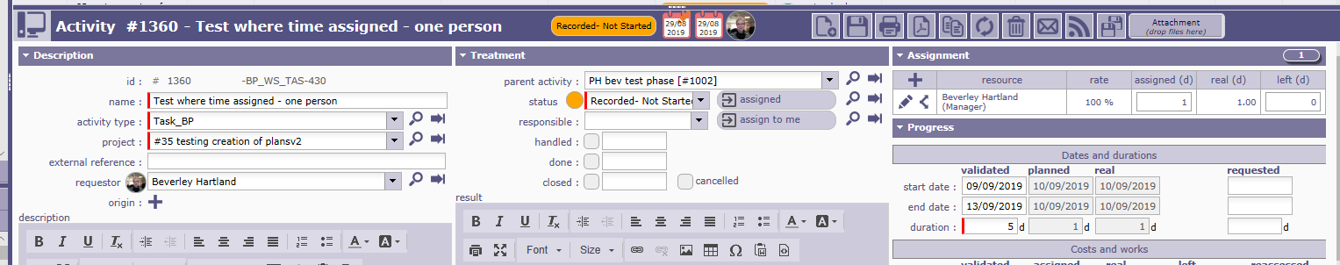
I then updated the required time as I had not finished the activity.
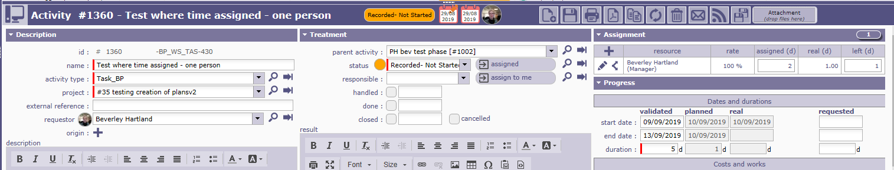
The planned end date did not update to when it is was originally required to be finished, even though the original planned end date was after the time recorded? The time sheet now indicates this activity is required to start and finish on 10th August not required to finish on 13th August!?

THIRD TEST (checking if doing activity in future made any difference to calculations and updates. It did not.)
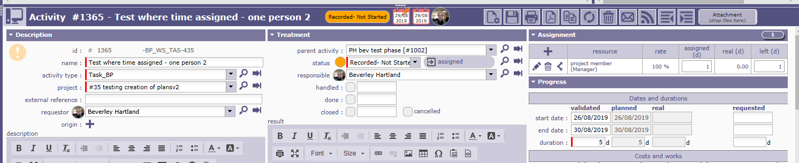
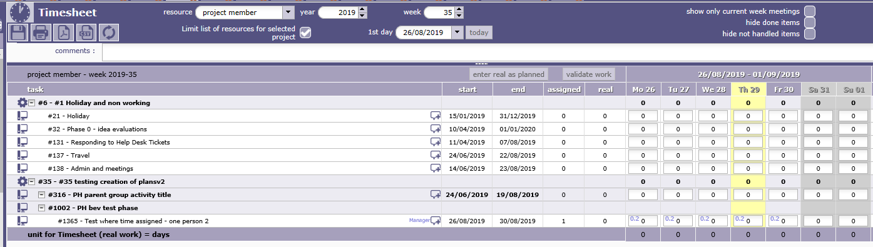

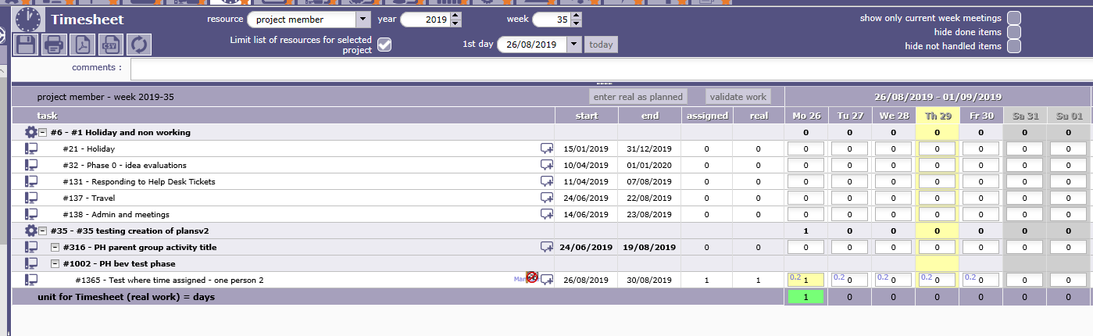
As expected time activity start and end date show as the date 1 day assigned time was recorded on 26th august. However in fact activity was not finished so wish to show this in system and give user completing time sheets idea when activity needs to be completed by
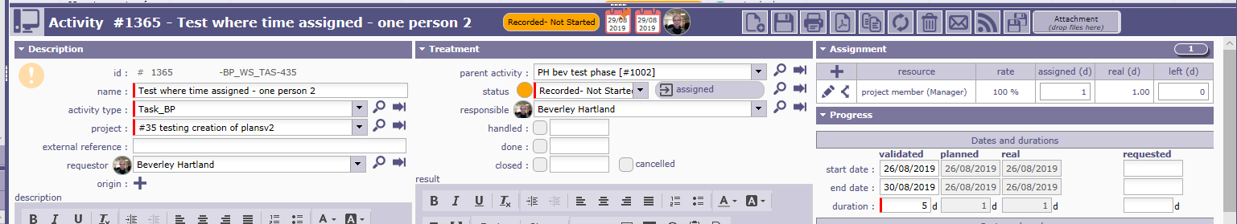
If I try increasing the assigned time as I have not finished the activity. The planned end date still does not appear to correct back to original planned end date.
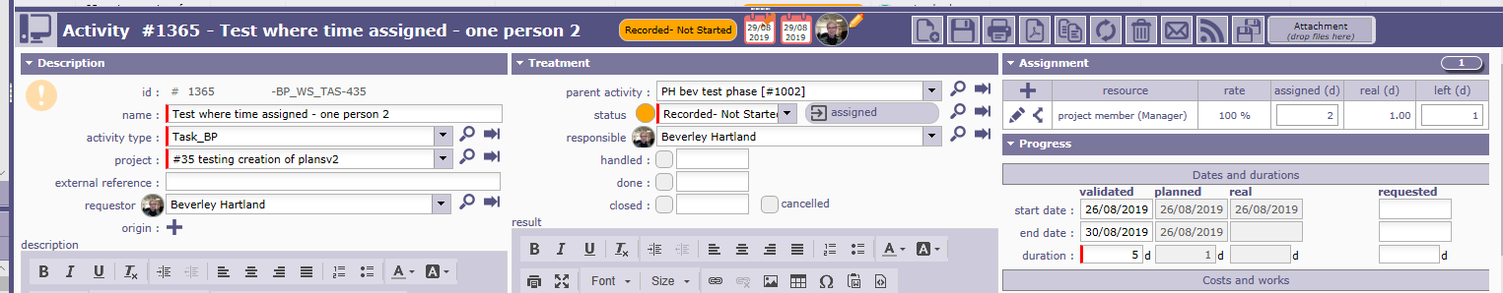

The user can not see when in the time sheet activity needs to be completed by as updated planned dates are shown as start and end date of 26th Aug, not the end date of 30th August!.
