Issues with Links being picked up in Emails
- Not all links elements have been listed.
- How to add the planned due/end date of the linked element to the email.

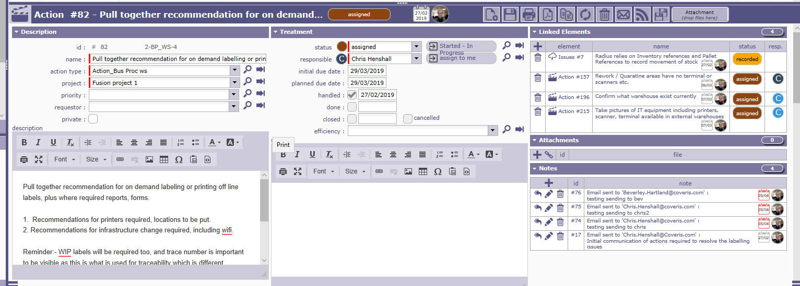
Email received
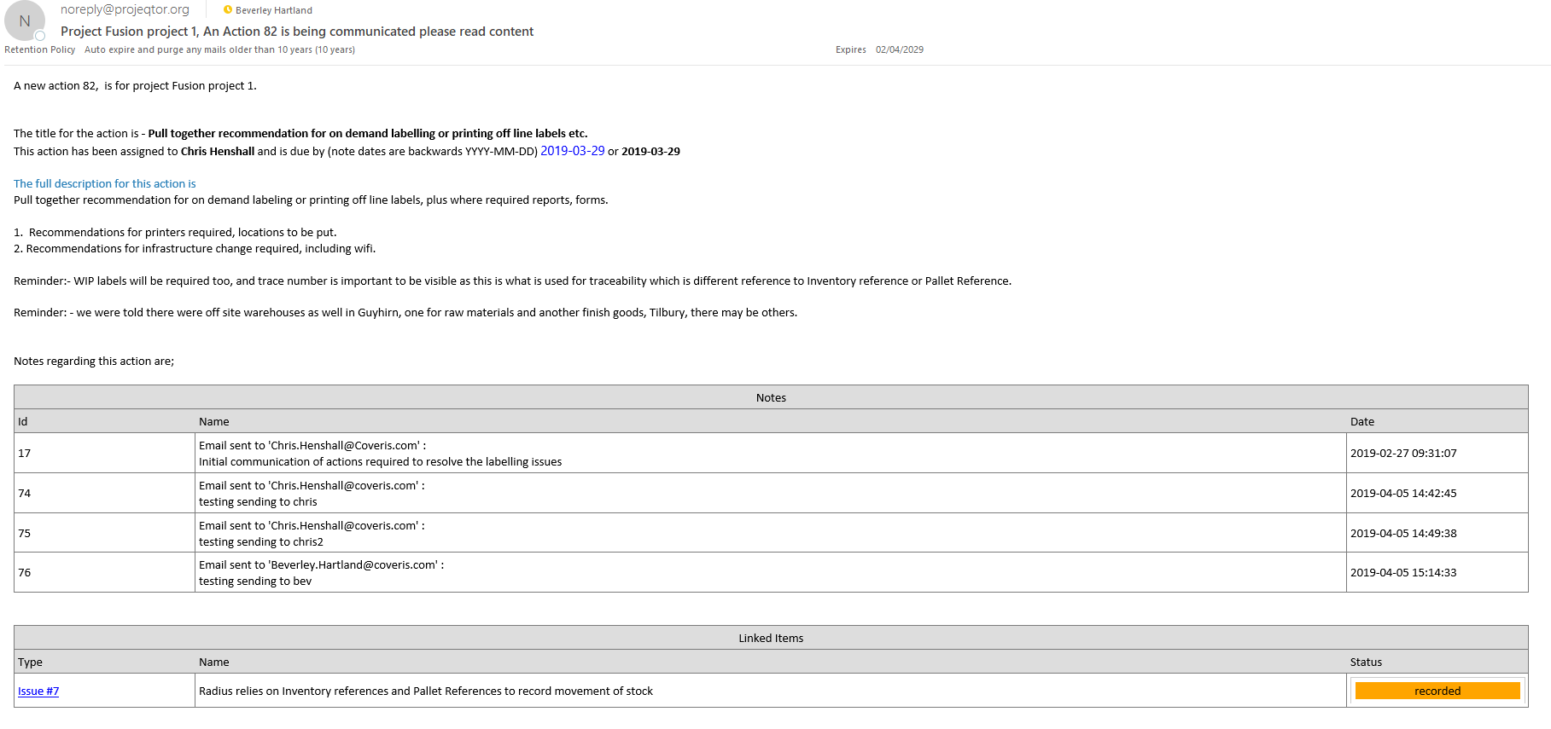
I would have expected all 4 linked elements to have been listed in the email in the lined items box.

Issue 7, action 157, 196, 215
The email template which was used was.
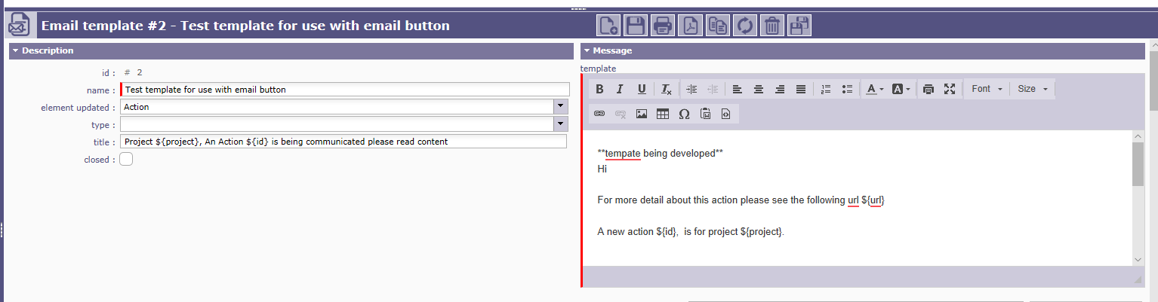

**tempate being developed**
Hi

For more detail about this action please see the following url ${url}

A new action ${id}, is for project ${project}.

The title for the action is - ${name}
This action has been assigned to ${responsible} and is due by (note dates are backwards YYYY-MM-DD) ${actualDueDate} or ${initialDueDate}

The full description for this action is ${description}

Notes regarding this action are;

${NOTE}

${LINK}

