Building of email template for use when manually sending an email whilst in an action.
ISSUES –
Can not find a way to show the linked elements planned end dates?
{History} does not appear to work and give latest change for the action element.
Tested this with action
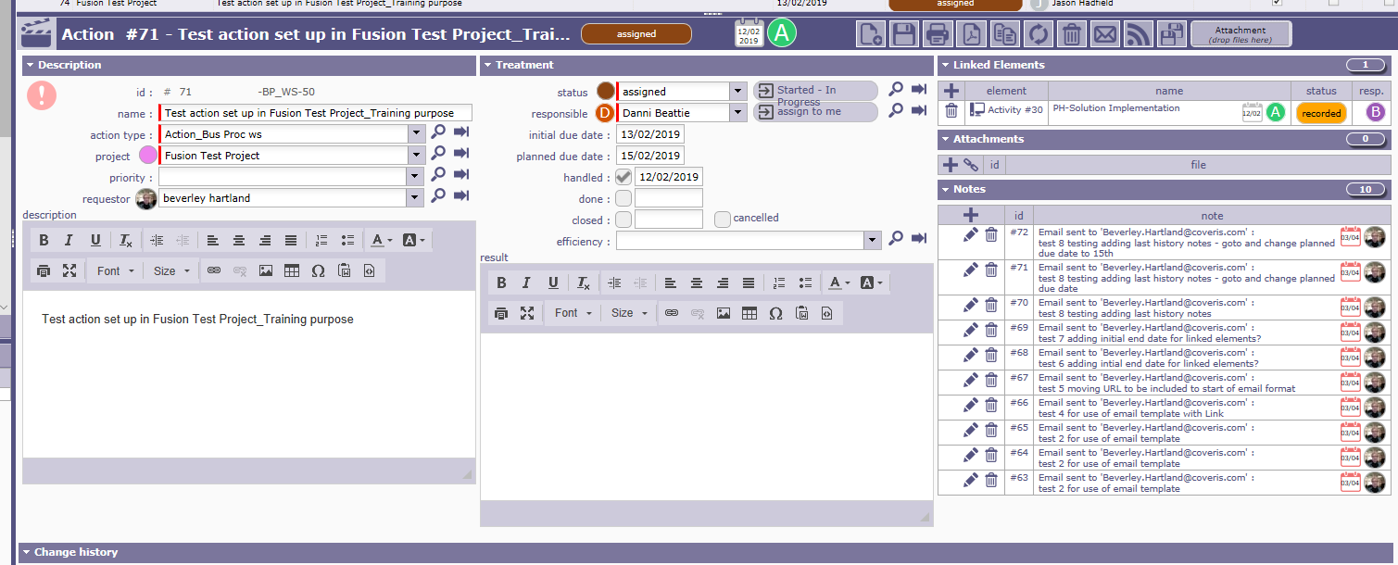

Linked elements details are
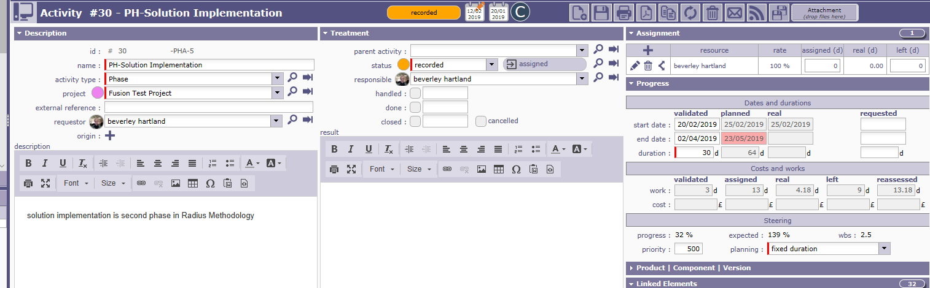

EMAIL TEMPLATE CREATED IS
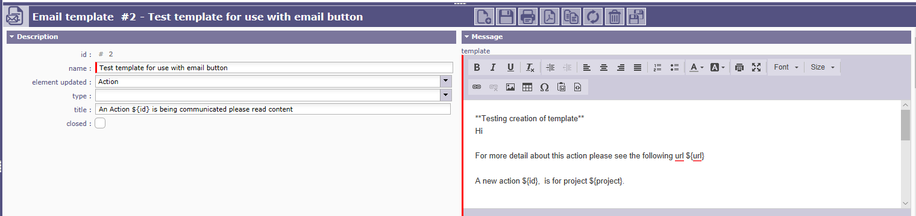
Email template contains
Hi

For more detail about this action please see the following url ${url}

A new action ${id}, is for project ${project}.

The title for the action is - ${name}
This action has been assigned to ${responsible} and is due by (note dates are backwards YYYY-MM-DD) ${actualDueDate} or ${initialDueDate}

The full description for this action is ${description}

Notes regarding this action are;

${NOTE}

${LINK} {goto}

${HISTORY}

This produces the following email

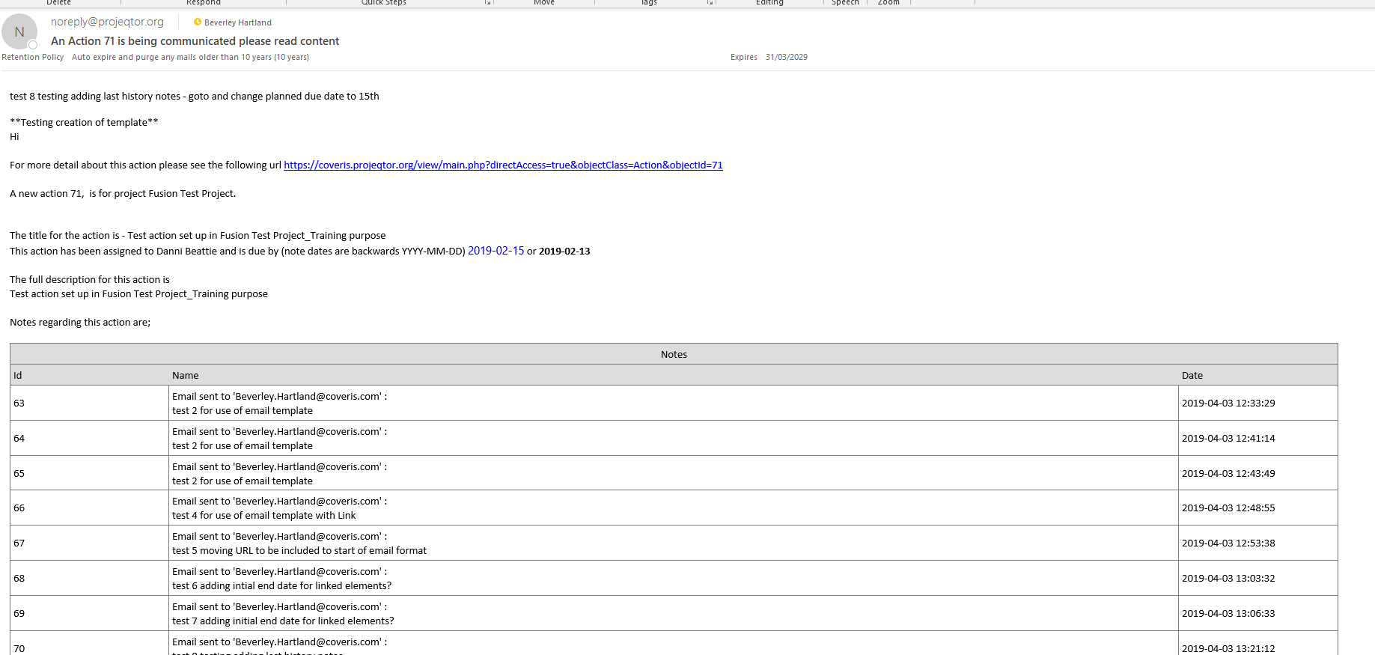

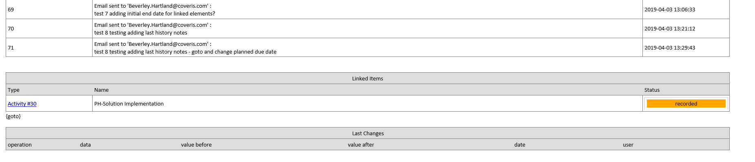

We need to be able to communicate what the linked elements are and when they are planned to be completed the planned end/due dates for these linked elements. Is there a way to do this when we create template, for use when emailing an element to someone.

