Still trying to get Activities Planned End and Start date extracted for activities.

I have tried the suggestion of object.activityplanningelement.plannedEndDate. But still does not extract any information.

However get;



Template I used was set up as follows





**The template report run was set up as follows.**

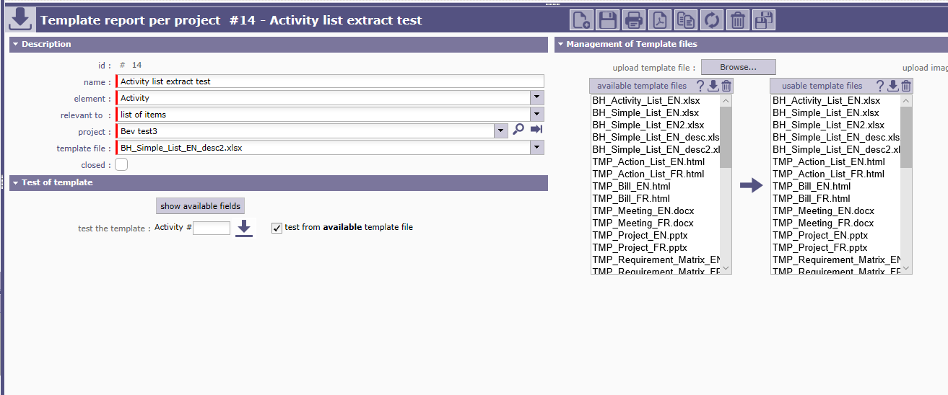

**As you can see the activity #109 does have a planned end date for project Bev test3**

