LINK – For DELIVERABLE 1 not correct, it should give details of Action #12, currently states Deliverable #1 as linked?

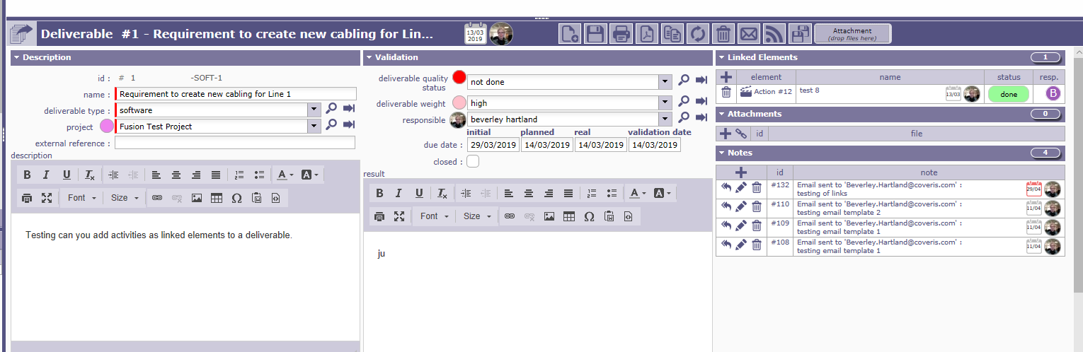

Generated an email with
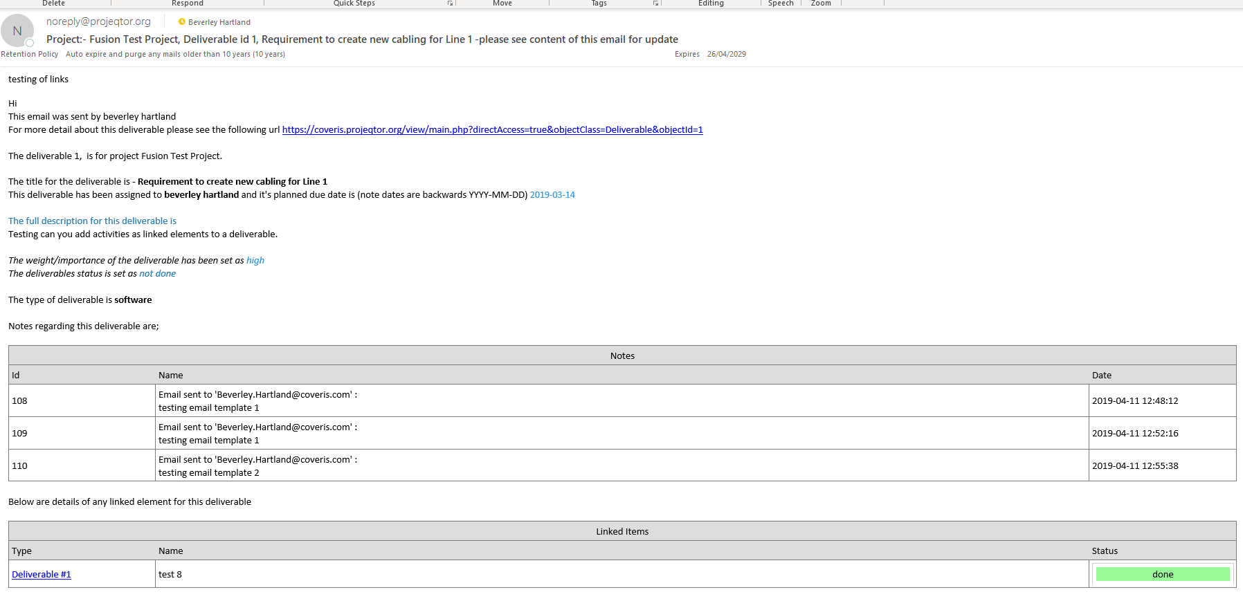

Should have been Action #12

See below for details of the Email Template

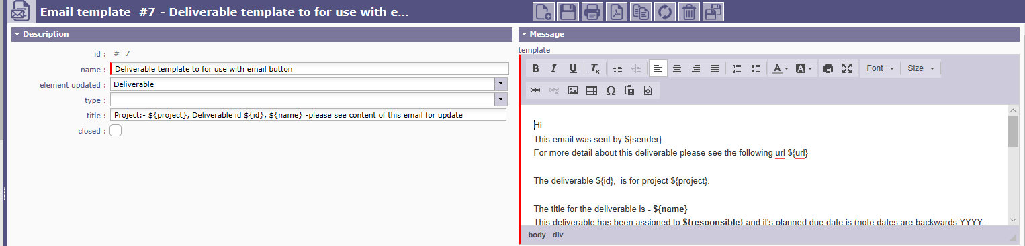

Hi
This email was sent by ${sender}
For more detail about this deliverable please see the following url ${url}

The deliverable ${id}, is for project ${project}.

The title for the deliverable is - ${name}
This deliverable has been assigned to ${responsible} and it's planned due date is (note dates are backwards YYYY-MM-DD) ${plannedDate}

The full description for this deliverable is ${description}

The weight/importance of the deliverable has been set as ${nameDeliverableWeight}
The deliverables status is set as ${nameDeliverableStatus}

The type of deliverable is ${nameDeliverableType}

Notes regarding this deliverable are;

${NOTE}

Below are details of any linked element for this deliverable

${LINK}

SECOND TEST WITH A DELIVERABLE WITH MULTIPLE ACTIONS LINKED

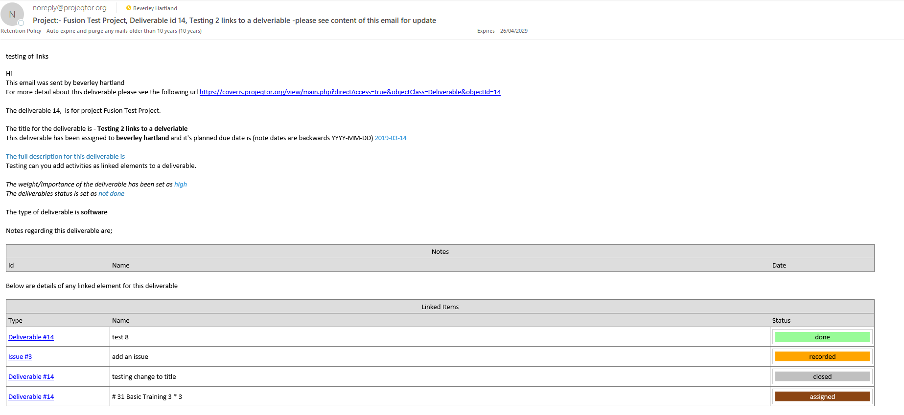

Looks like all actions and activity are being reported as Deliverable not actions ref.

