LINK – For Project Expense 1 not correct, it should give details of Action #27 and Deliverable #14 as linked?

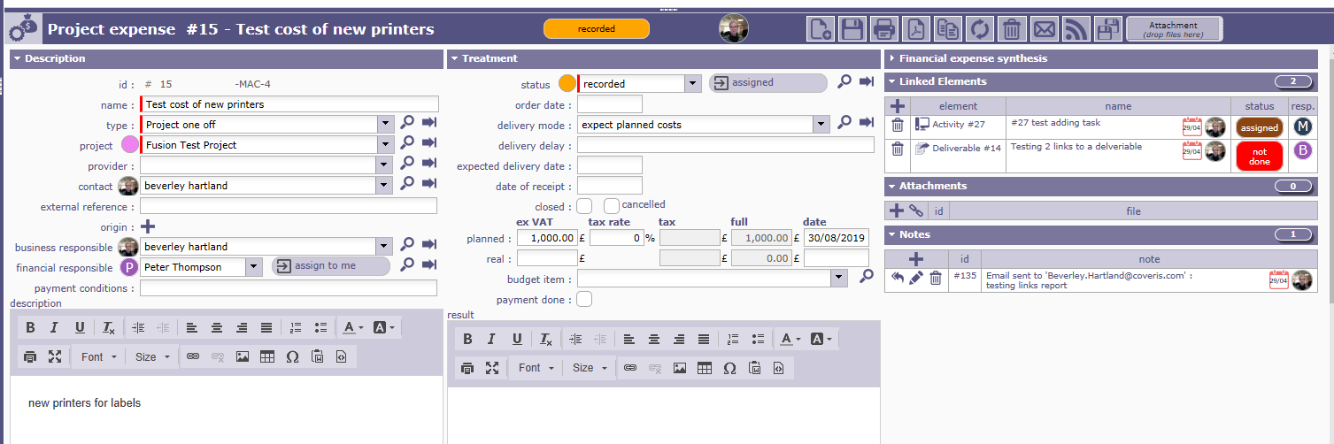

Generated an email with

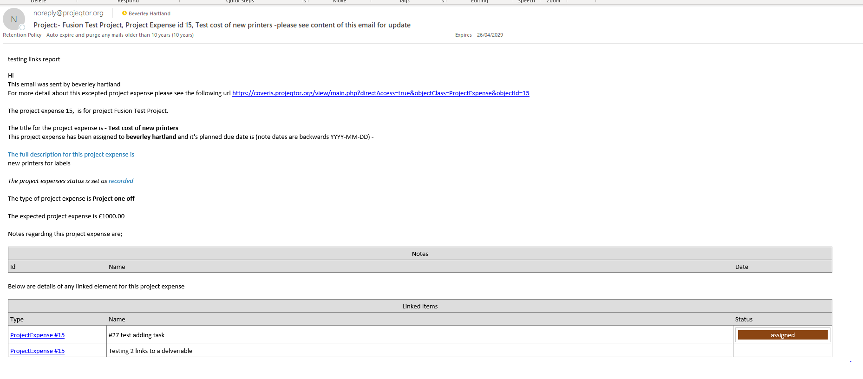

Should have been Activity # 27 and Deliverable #14

See below for details of the Email Template

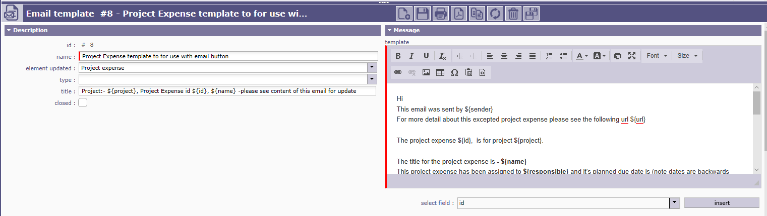

Hi
This email was sent by ${sender}
For more detail about this excepted project expense please see the following url ${url}

The project expense ${id}, is for project ${project}.

The title for the project expense is - ${name}
This project expense has been assigned to ${responsible} and it's planned due date is (note dates are backwards YYYY-MM-DD) ${deliveryDate}

The full description for this project expense is ${description}

The project expenses status is set as ${nameStatus}

The type of project expense is ${nameProjectExpenseType}
The expected project expense is £${plannedAmount}

Notes regarding this project expense are;

${NOTE}

Below are details of any linked element for this project expense

${LINK}

SECOND TEST WITH A PROJECT EXPENSE WITH MULTIPLE Elements LINKED
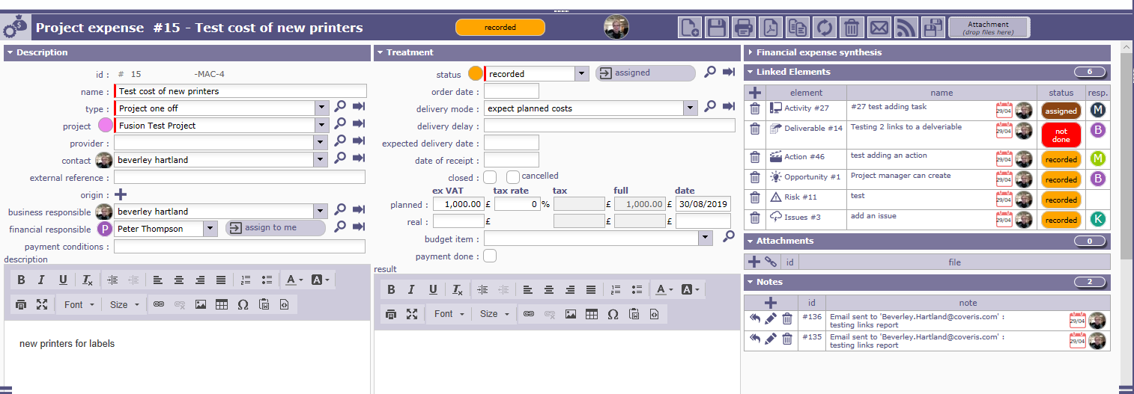
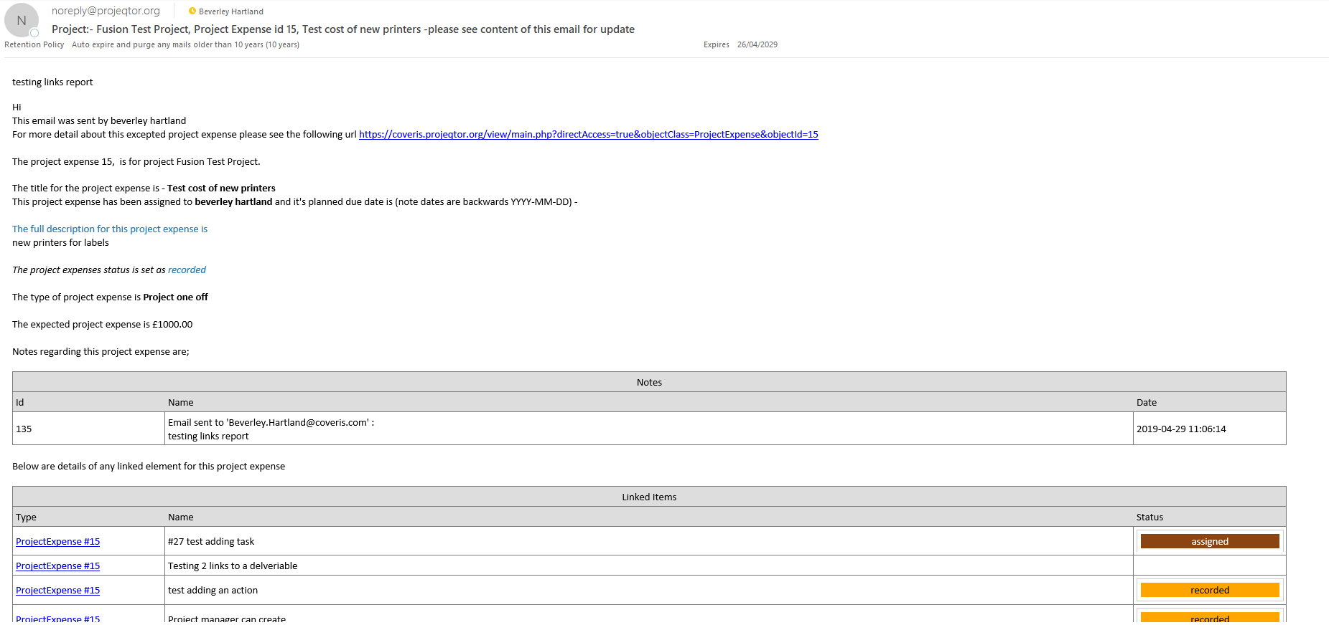

Project Expense #15 should be above
Activity #27
Deliverable #14
Action #46
Opportunity 1
Issue #3

