Another example of problem with link not working in email generated from templates

HI
I have already reported that the action email appeared to only have one of the links in it. Ticket –Ticket #3943
However, I am just tried creating an email template for an issue.
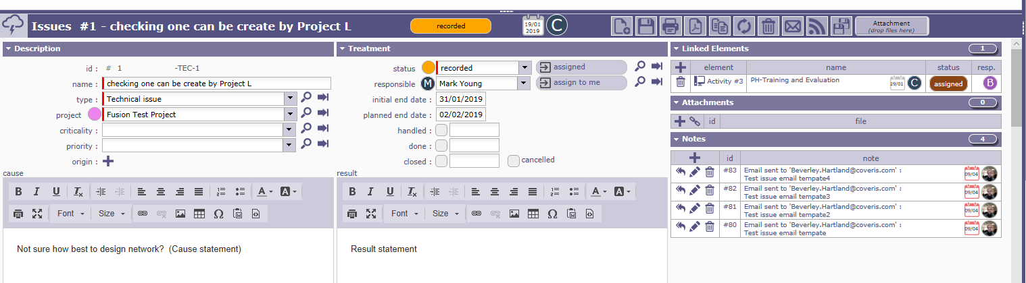

However the email template did not print any linked elements.

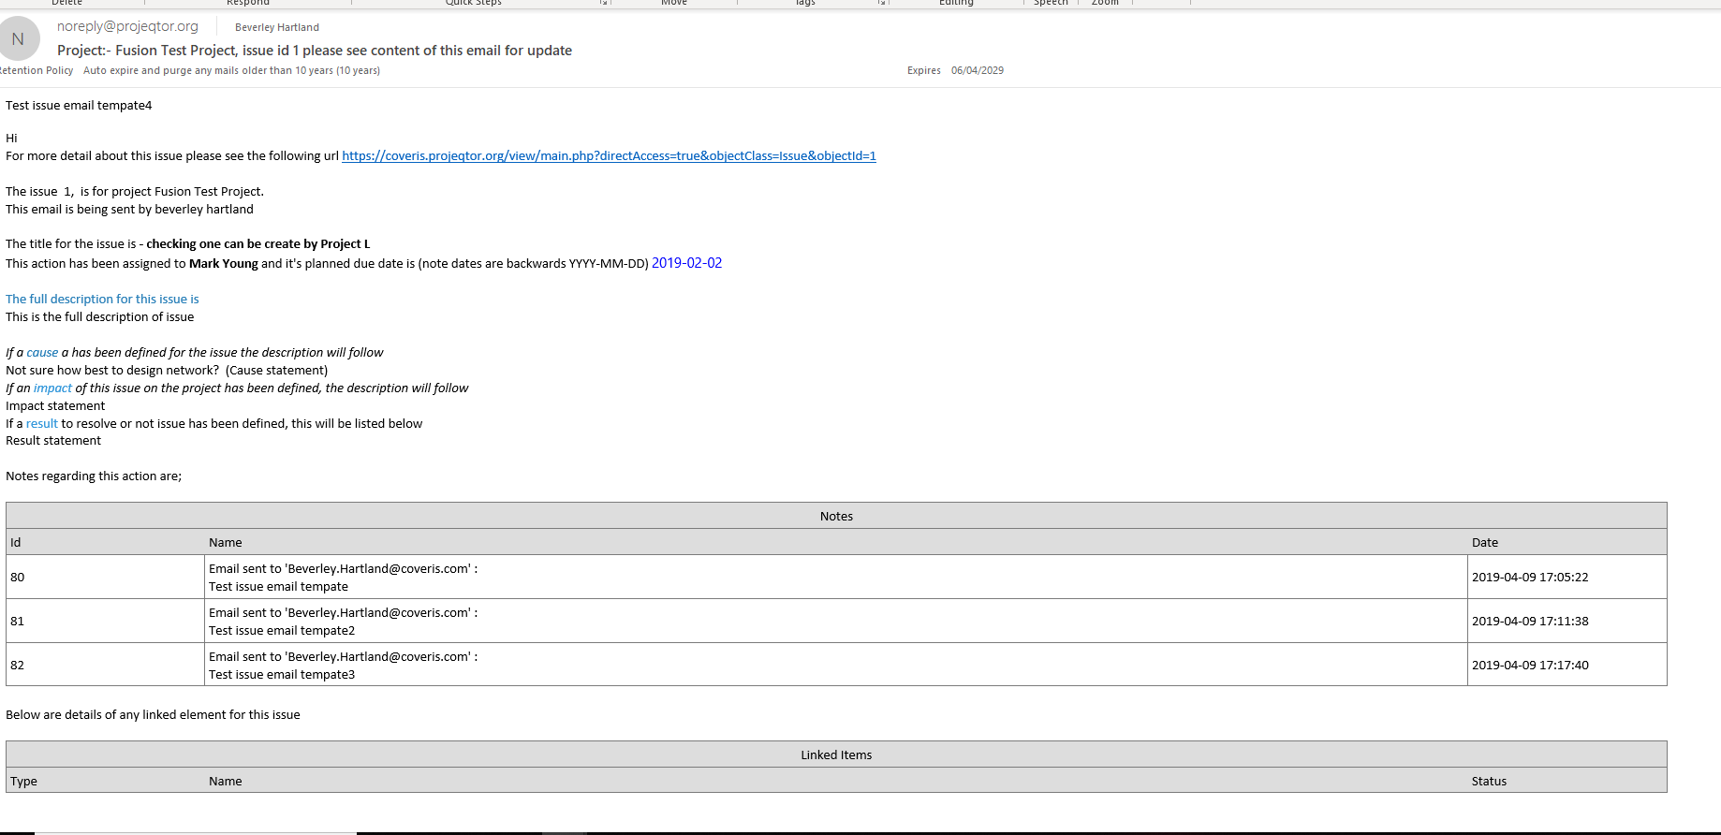

The email template used was

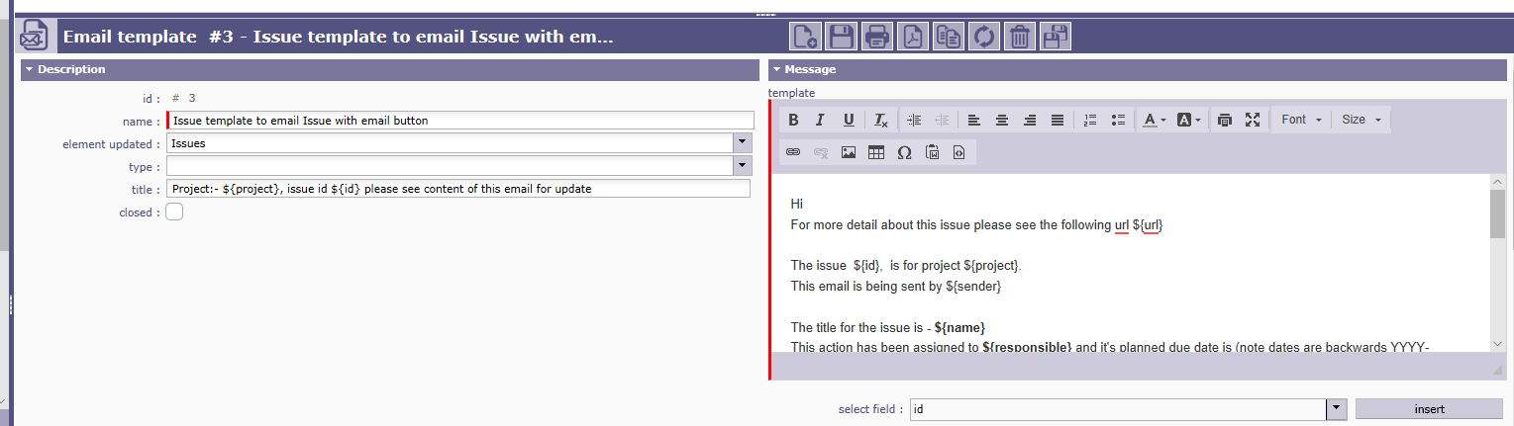
Hi
For more detail about this issue please see the following url ${url}

The issue ${id}, is for project ${project}.
This email is being sent by ${sender}

The title for the issue is - ${name}
This action has been assigned to ${responsible} and it's planned due date is (note dates are backwards YYYY-MM-DD) ${actualEndDate}

The full description for this issue is ${description}

If a cause a has been defined for the issue the description will follow ${cause}
If an impact of this issue on the project has been defined, the description will follow ${impact}
If a result to resolve or not issue has been defined, this will be listed below
${result}

Notes regarding this action are;

${NOTE}

Below are details of any linked element for this issue

${LINK}

Thanks Bev

