Another example of problem with link not working in email generated from templates RISK this time.

HI
I have already reported that the action email appeared to only have one of the links in it. Ticket –Ticket #3943
However, I am just tried creating an email template for a risk.
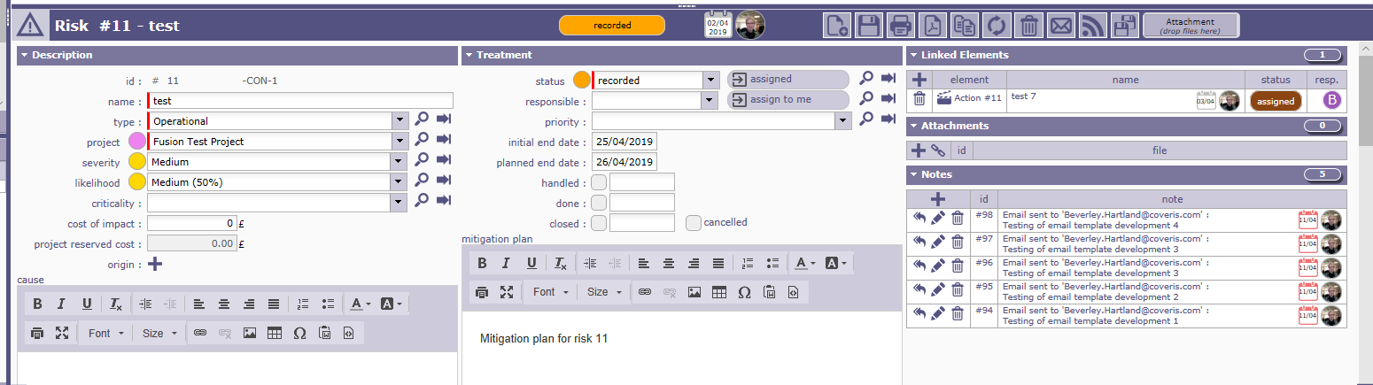

However the email template did not print any linked elements.

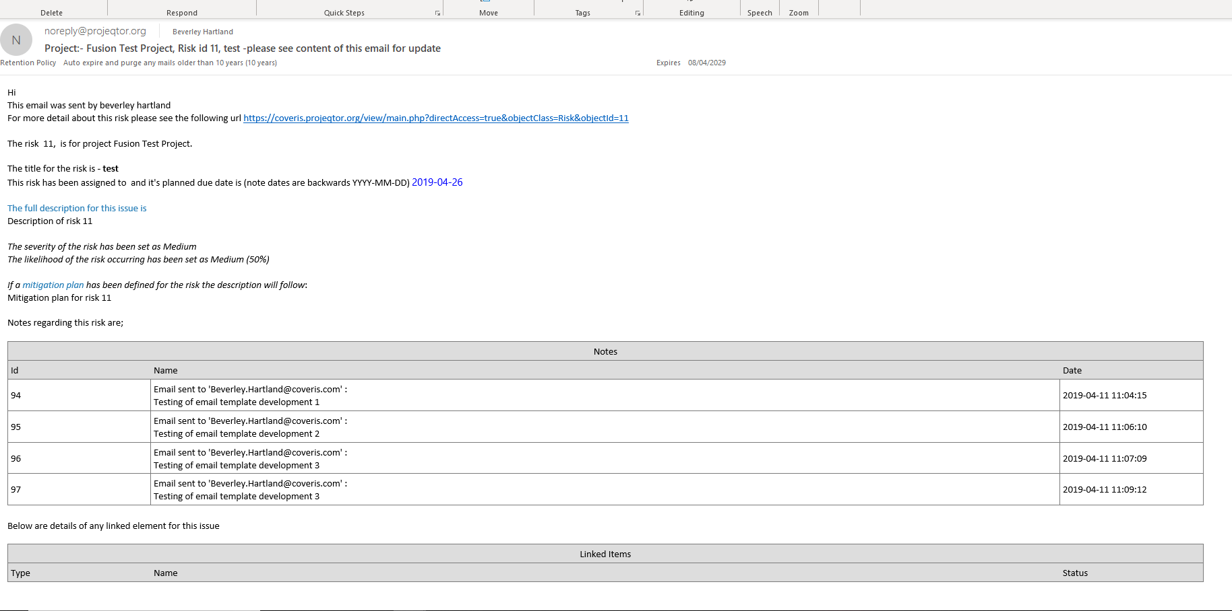

The email template used was

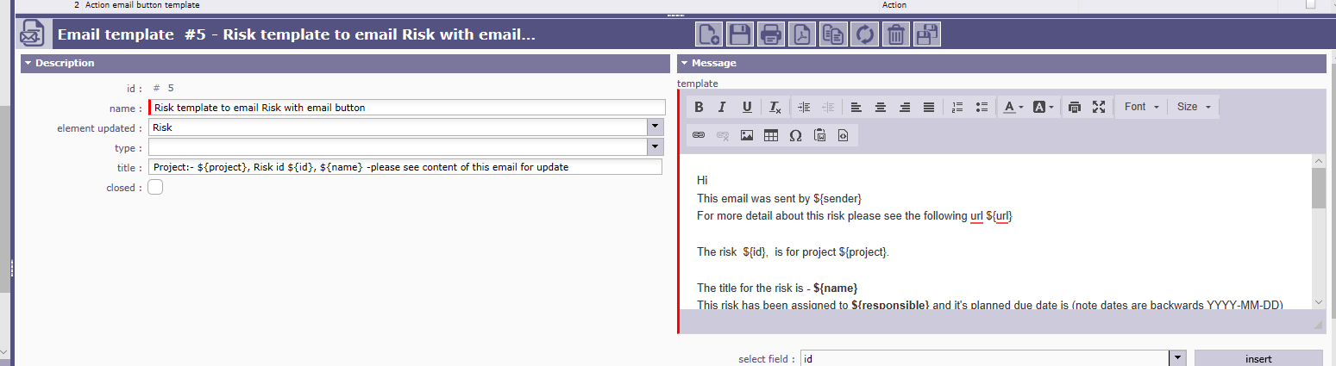
Hi
This email was sent by ${sender}
For more detail about this risk please see the following url ${url}

The risk ${id}, is for project ${project}.

The title for the risk is - ${name}
This risk has been assigned to ${responsible} and it's planned due date is (note dates are backwards YYYY-MM-DD) ${actualEndDate}

The full description for this issue is ${description}

The severity of the risk has been set as ${nameSeverity}
The likelihood of the risk occurring has been set as ${nameLikelihood}

If a mitigation plan has been defined for the risk the description will follow:
${mitigationPlan}

Notes regarding this risk are;

${NOTE}

Below are details of any linked element for this issue

${LINK}

Thanks Bev

