Predecessor – Element,

List of elements shows all e.g activities for all projects not just the one I am creating a plan for.

Hi
I have found this issue on a number of occasions, when I am in Global Planning view, adding a new activity and to this activity a predecessor, in the drop down list it first shows all activities for all projects I think (at least all some from more than the project selected, if I come and go in again to the drop list it then shows just the activities for that project. I would have expected just the non-closed ones, which is what I get. It should do this the first time the list appears.
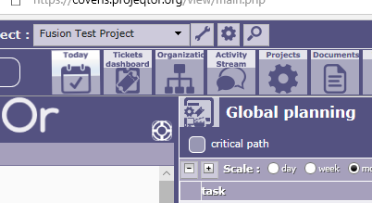

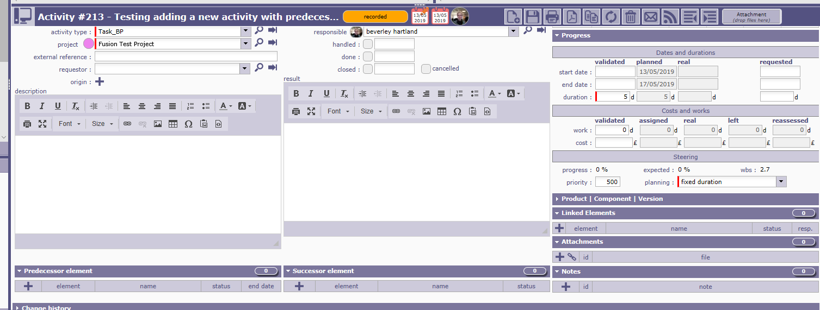
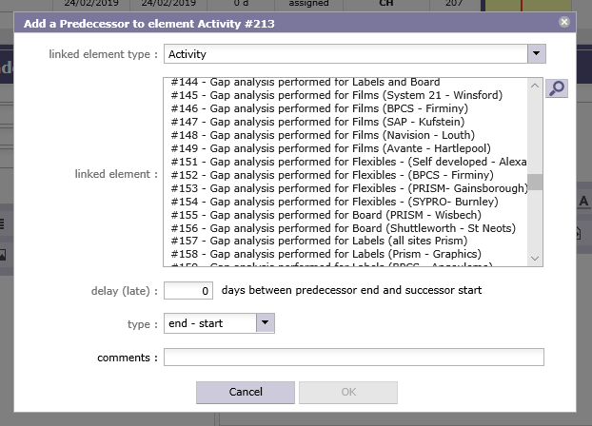

The second time I go into the dropdown I get
