Problem in TimeSheet – Closed items not disappearing from view consistently

1. Added time in the timesheet for this activity and then clicked on it and changed the status to closed.

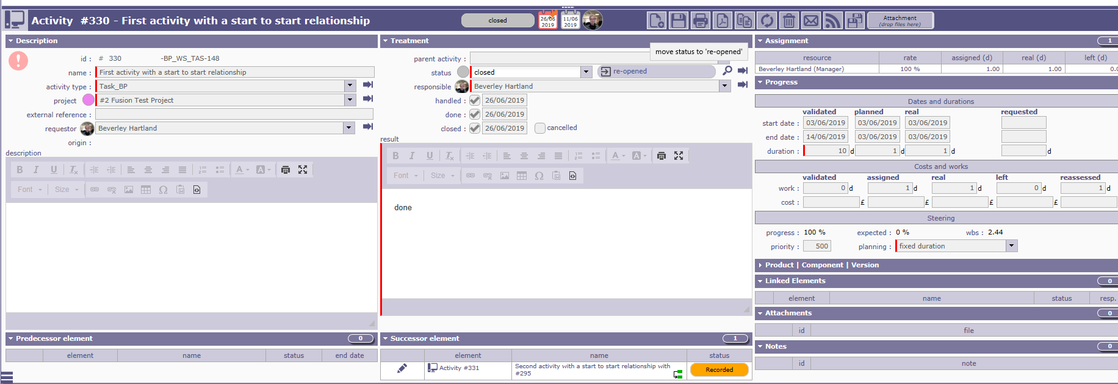

1. Then when viewed in time sheet it looked like.

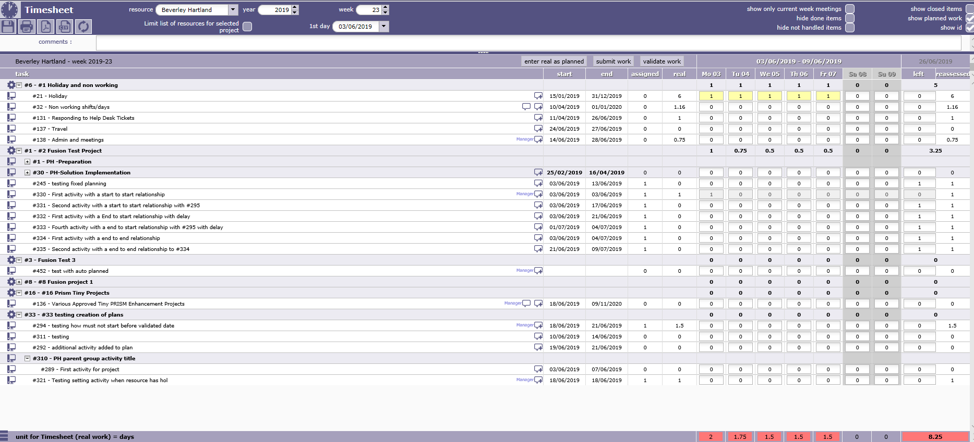

I have tried –

1. refreshing view (no change still shows closed activity)
2. coming out of the time sheet and the re-entering this screen still shows closed activity #330.
3. Switching on the show closed items flag and then off again. (more items where shown when show closed items was switched on.) However #330 still showed in gray when show closed items was switched off again.