Problems trying to TEST the generation and creation of a Report template in DEMO – Report Template Plug In

I have managed to generate a report test extract file using the supplied templates which is similar to the one I should like. However first change was to add a title.
I have created a new .xlxs template, with a tille - BH_Simple_List_Title_EN.xlxs
I can browse and upload this file to templates

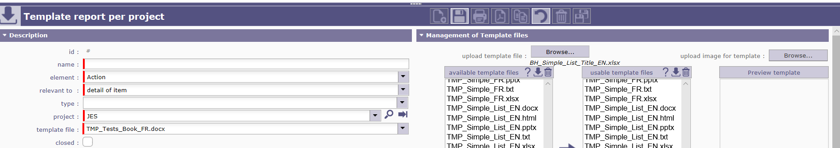

However after this I have a number of problems.
- If I try and select image for template I get the error message below.
- The uploaded template is not in the available template files list.
- When in the description section, if you try and select the template file I uploaded it is not in the list to enable it to be select.
