Problems with use of time sheet and plans.
How to stop the planned end date changing when activity is not done, completed?
We are attempting to start getting users to record actual time taken for tasks.
However we have 2 difficultites, a. project managers have to go through another line manager to agree and arrange for staff to do activities. To overcome this if the manager is not about when team are working on project plan. We have asked the project manager to plan in the activities when they wish to do these with the managers name assigned. The manager will then review the plans, and re-assign the activities to a team member and assign a work time if known at that point. (Otherwise the project plans will be looking at the managers availability, and suggesting planned time due to them being booked on other projects.)
However most of the IT resources have to do support, help desk tickets too, and the work time might be difficult to estimate. So we have tried assigning the activity to a user, who then records the actual time and continues to do this until the activity is done. However what this did was change the planned dates, to the start and end date when time was recorded, when there was still work they had to do, the user did not set the activity as done. We would like the planned end date to remain as originally planned. It is not always possible to get a planned assigned time agreed and recorded before the activity has to appear on the users timesheet.
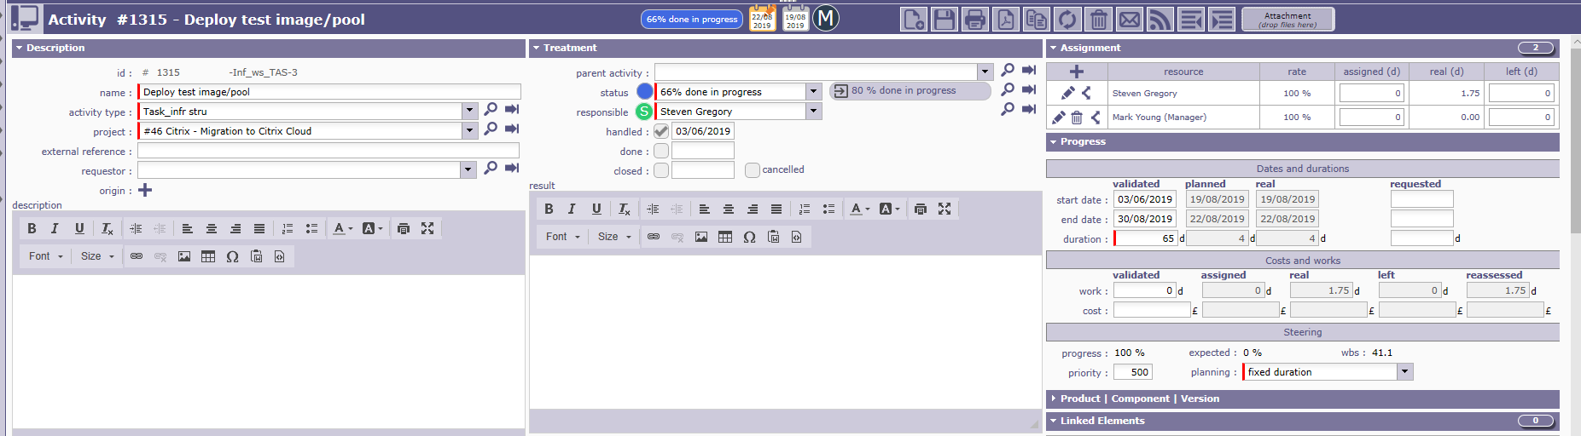
The other way we looked at this was by putting an assigned time and the user recording actuals until the activity is done. When it is done for the user to change the status to done. However again, even those not all the required work time was recorded as actuals. The planned date change to the start date of the first time entered and the end date of the last time entered. I would have expected the planned end not to change as there is still work to be booked.

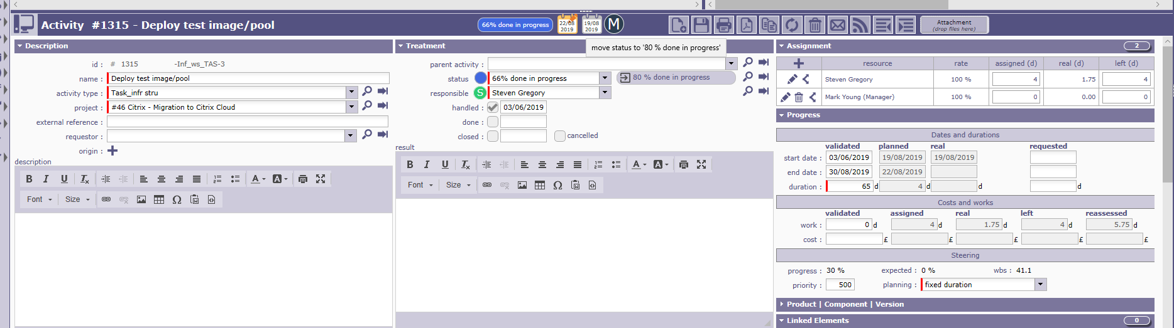

This is the time sheet Steven Gregory completed.
