ProjeQtOr

**TimeSheets – with no project activities appears in time sheet when at least one should.**

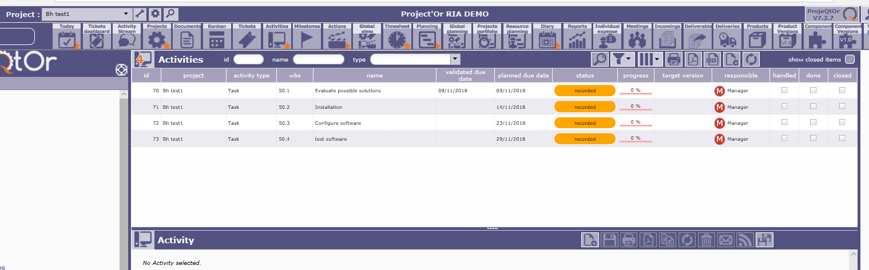

Project and any activities do not appear in sheet below, which could be correct as due date Is not in this week.

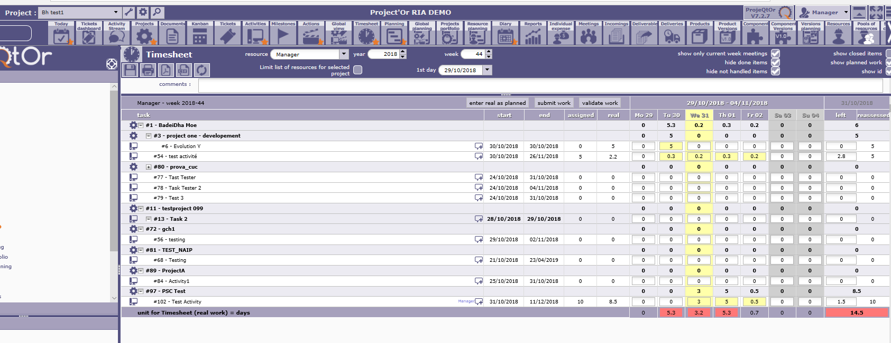

Project and any activities do not appear in sheet below, which could be correct as due date Is not in this week.

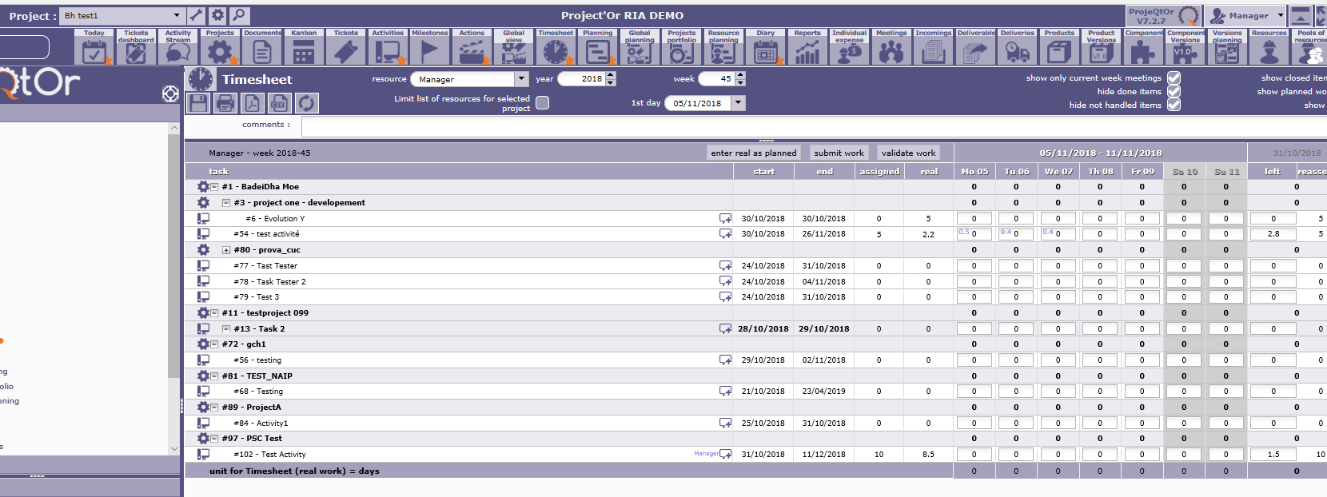

However at least one of the project “Bh test 1” at least one activity should appear on time sheet for manager!? However none are listed.