- Some of employees can’t take paid leave
- Parameters for earned leave rights :
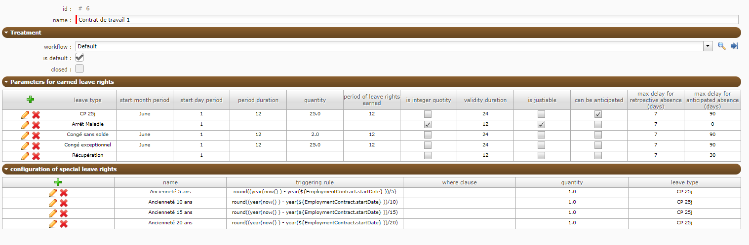

Case 1 : Employees with remaining days
Start Date 04/03/2019 (before 01/06/2019)
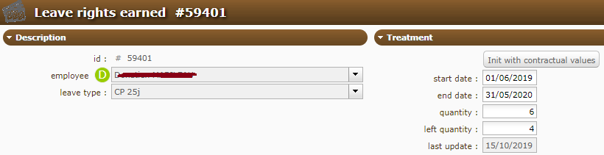
Nothing in the log except this message : « Can’t take more leaves »

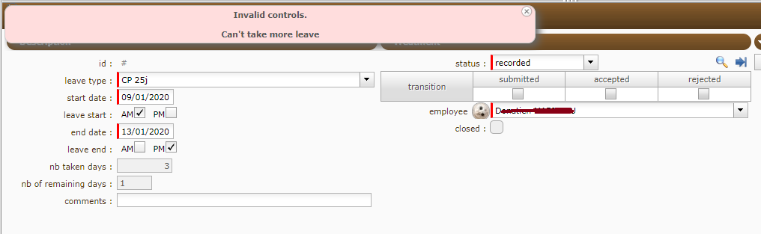
- Probably beacuse it still include WE ?

Case 2 : Employees without remaining days
Start Date 28/10/2019 (After 01/06/2019)
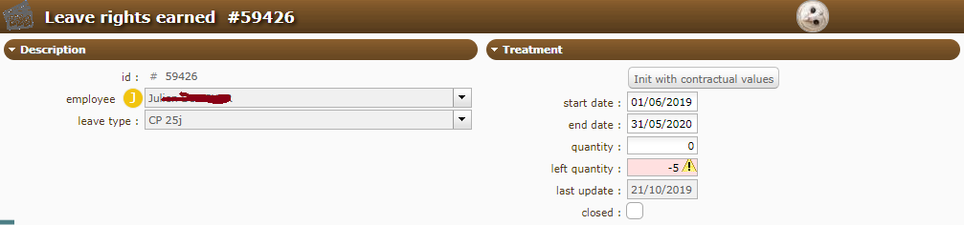
He took 5 days on december but can’t take other paid leave :
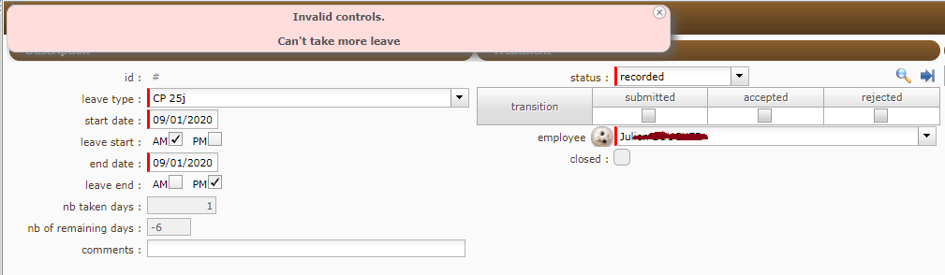

Nothing in the log except this message : « Can’t take more leaves »
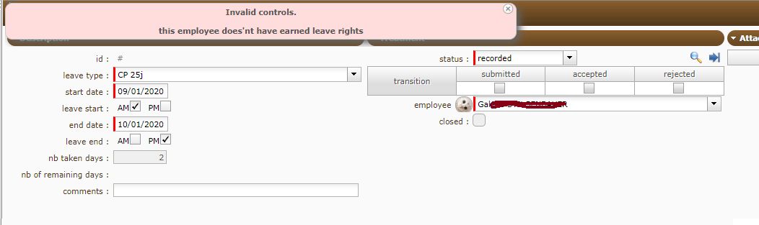

In the both case, employee could take paid leaves even with a negative left quantity.
How does work the mix between calculation of the leave rights earned and the possibility to take anticipated leaves.

