I tried to modify the planing tab,

I tried to modify the field length

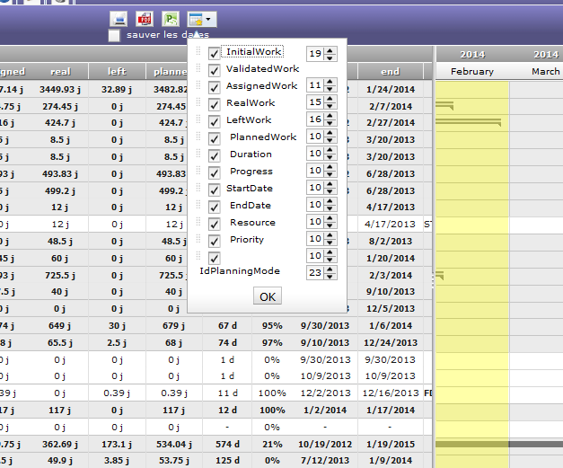

I created the class for these elements , I saved in the database , but I don’t know how i can modify the length of these fields

I saw that the server return a json file but I don’t know how change the length

I saw the jsonplaning.php but I didn’t find out to modify it .

Can you help me?