1 / Leave calendar as of December 2020 :
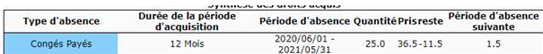
2 / Leave calendar to date : (Jan 12th, 2021)
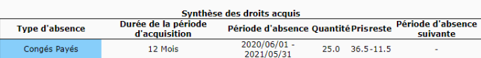
So, the leave can not be validated :
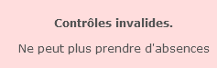

3 / The absence type parameters : (No change has been done between december and today)

