For exemple when we import project expense all seems to work well …
Example 27654010 :
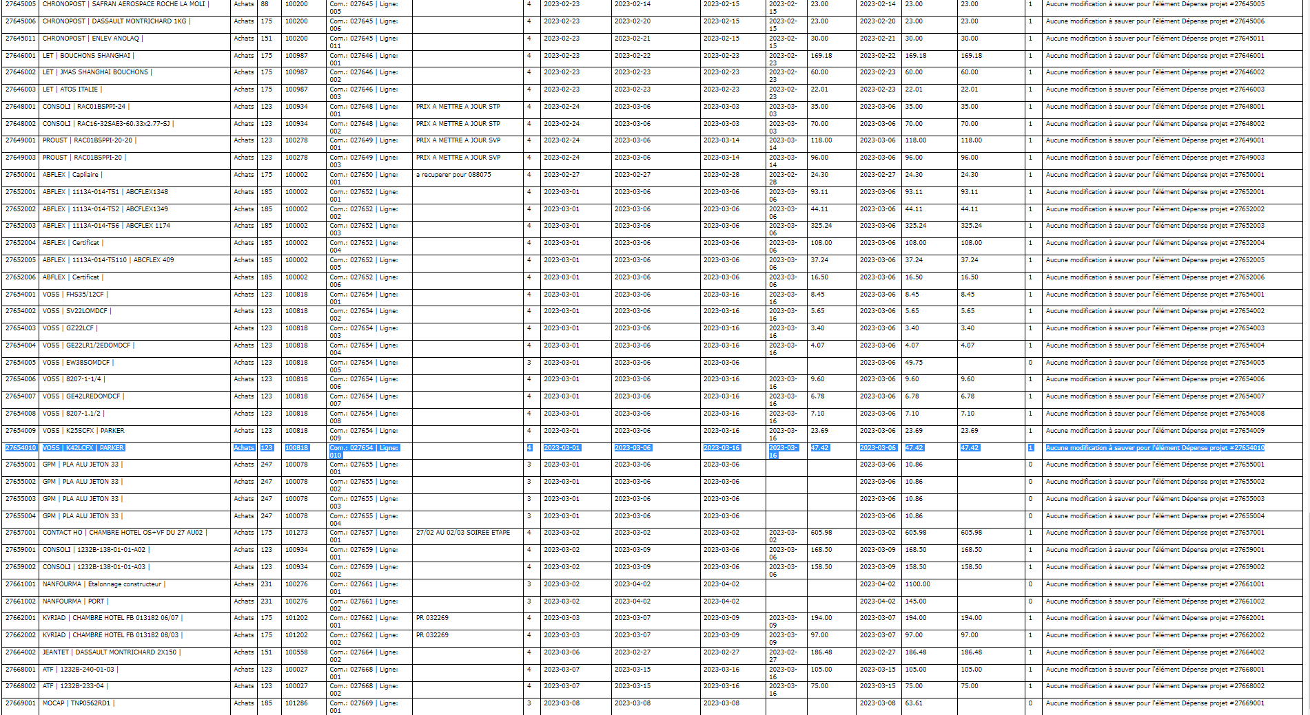
In project expense, i have :
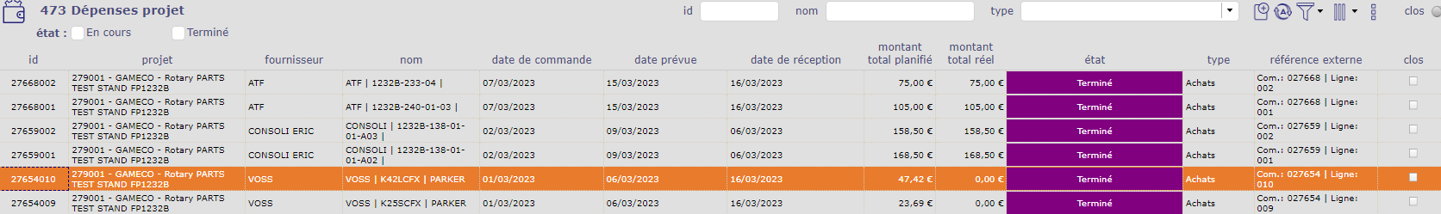
Total real cost is empty ( impossible cause when reception is done, we have a cost and date ! )
But import log say OK ??
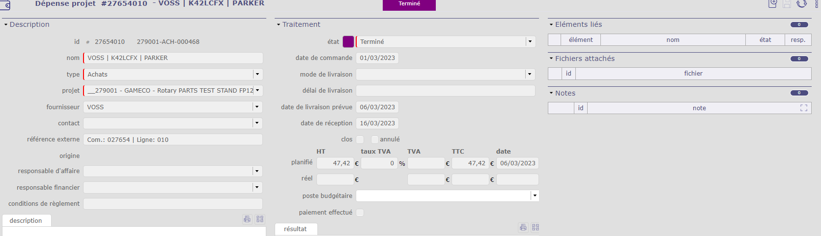
This trouble is not on 100%, but it happen a lot of time …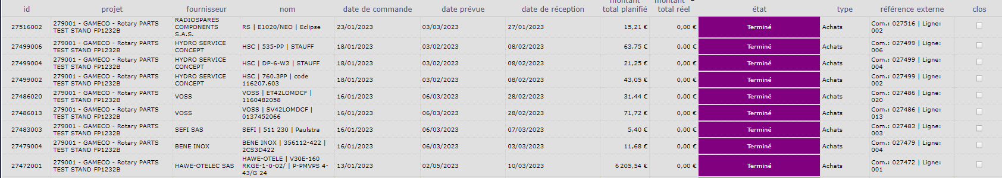
Info in database is not in line with log ?
Real date real amount … ?
