Create in BDD CEGID a Database called PROJEQTOR and a table « projeqtor » with 3 colums as follow :
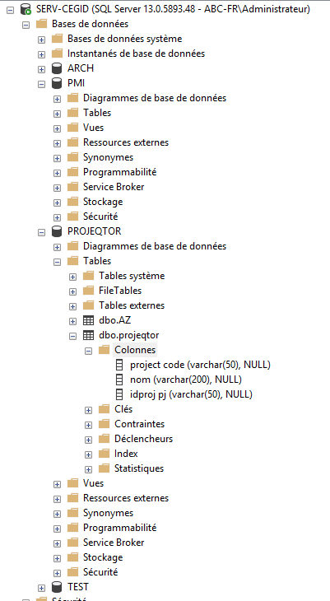
After that, you will find all script in .bat and SQL script associated to be adapt with your adresse & login & password of BDD.
Actual location of script is D:\extract\... and ip of projector serveur is .14 to be adapt
Of course you’ll need to put it on computer with shell exe for « mssql » (for CEGID) and « mysql » (for Projeqtor)

