Log :

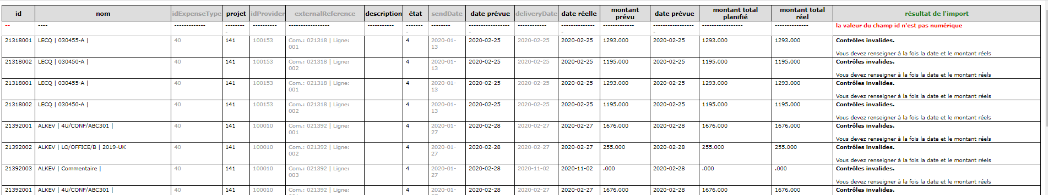

5 columm not taken into account

Previous format :

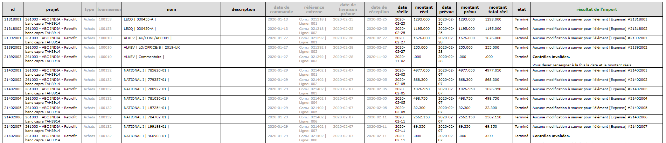

Same in fr

New SQL column name : ( as in table expense )



For individual expense same trouble in one columm

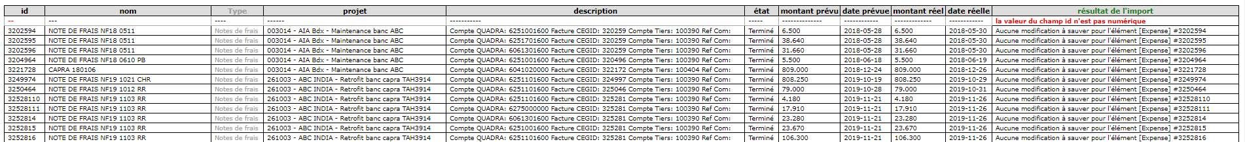

I put type in integer code … same trouble

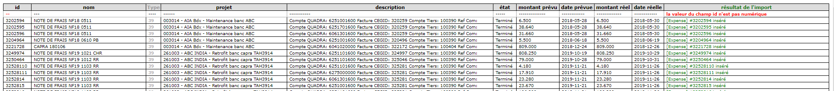

Despite information ‘datas updated’ and datas in table :

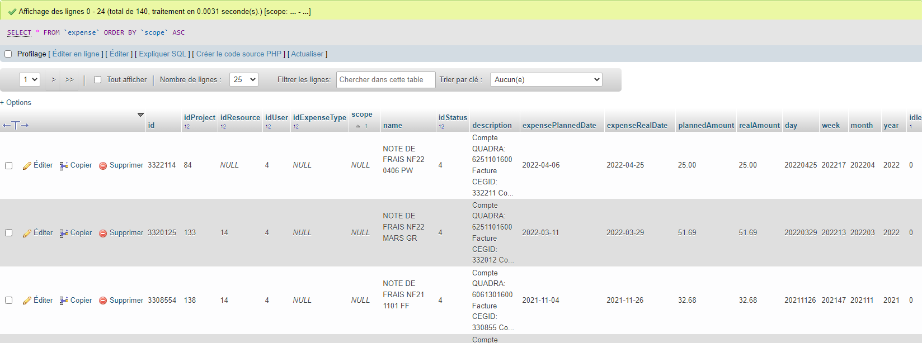

Nothing inside Projeqtor ….

