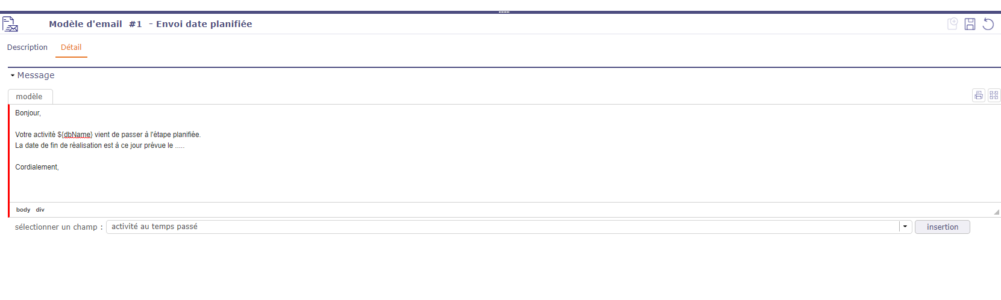

Which value should I select to have the plan end date in my email?