- Created filter as following in activities
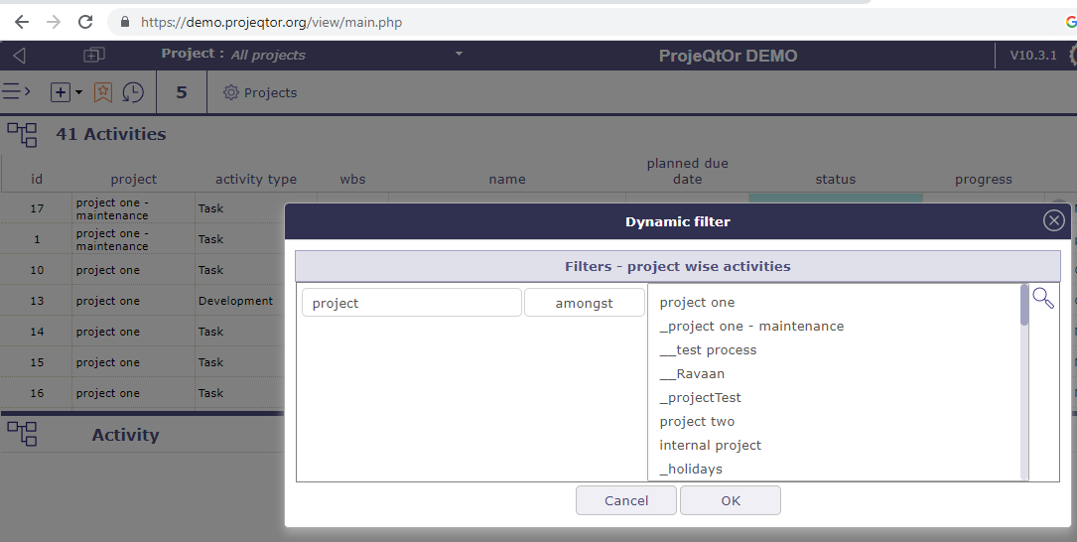

- Selected filter and choose project: “project two”, it shows result as in below image.
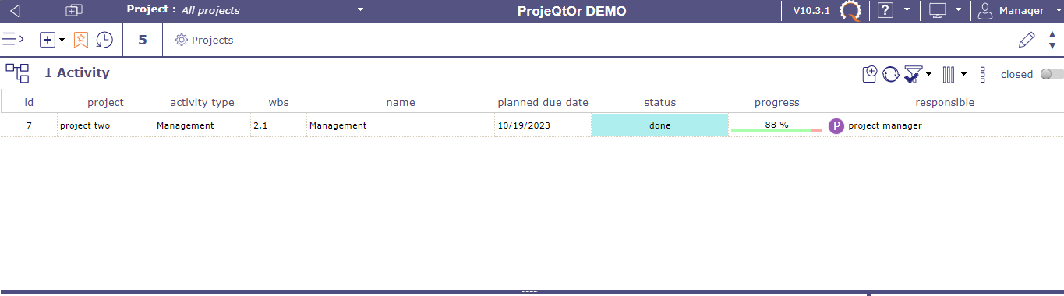

- Used quick search by input “bug fixing”

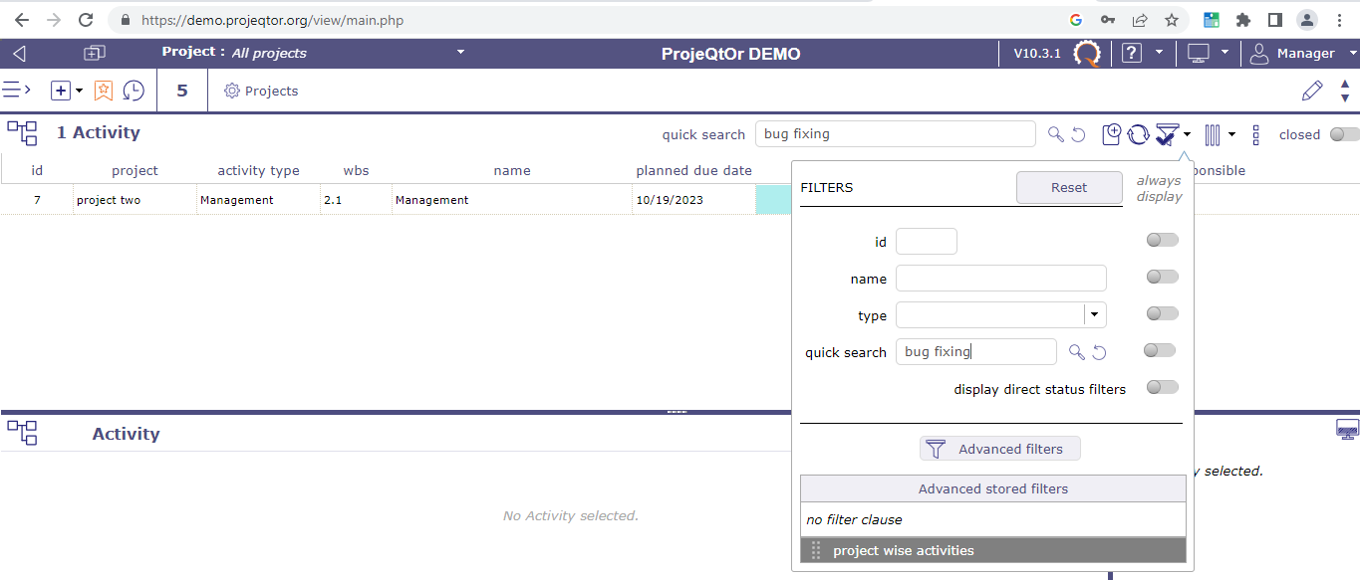

- Inspite of filter already applied for project (refer image in point 1), result showing for another project!
