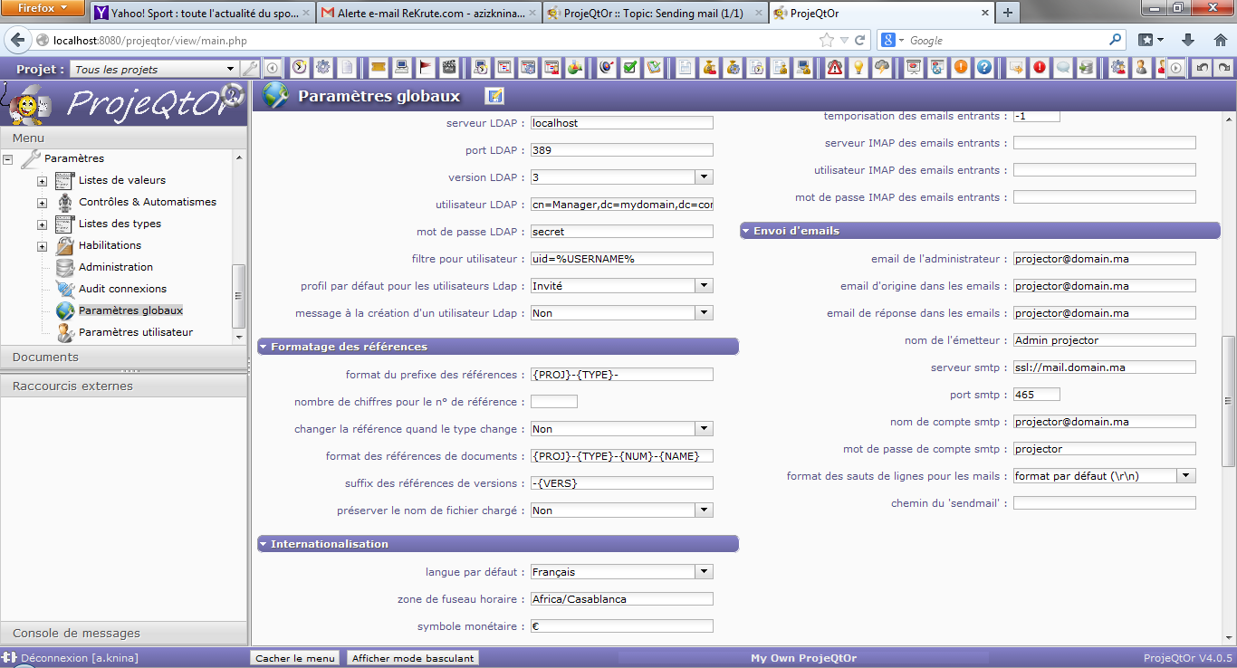

2013-12-05 11:45:49 \*\*\*\*\* ERROR \*\*\*\*\* Error sending mail

2013-12-05 11:45:49 \*\*\*\*\* ERROR \*\*\*\*\* SMTP Server : xx.xx.xx.xx

2013-12-05 11:45:49 \*\*\*\*\* ERROR \*\*\*\*\* SMTP Port : 465

2013-12-05 11:45:49 \*\*\*\*\* ERROR \*\*\*\*\* Mail stored in Database : #443

2013-12-05 11:45:49 \*\*\*\*\* ERROR \*\*\*\*\* PHPMail error : SMTP connect() failed.

2013-12-05 11:45:49 \*\*\*\*\* ERROR \*\*\*\*\* PHPMail debug : 2013-12-05 11:45:49 SERVER -> CLIENT:

2013-12-05 11:45:49 CLIENT -> SERVER: EHLO localhost

2013-12-05 11:45:49 SERVER -> CLIENT:

2013-12-05 11:45:49 SMTP ERROR: EHLO command failed:

2013-12-05 11:45:49 SMTP NOTICE: EOF caught while checking if connected

SMTP connect() failed.