My pool of resource 5 ETP :
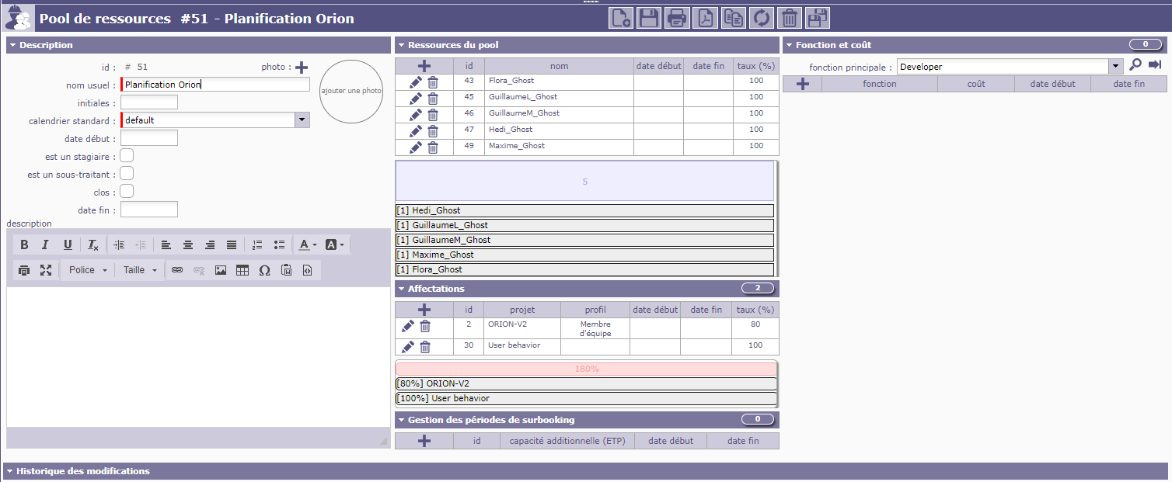
My synthese of availability
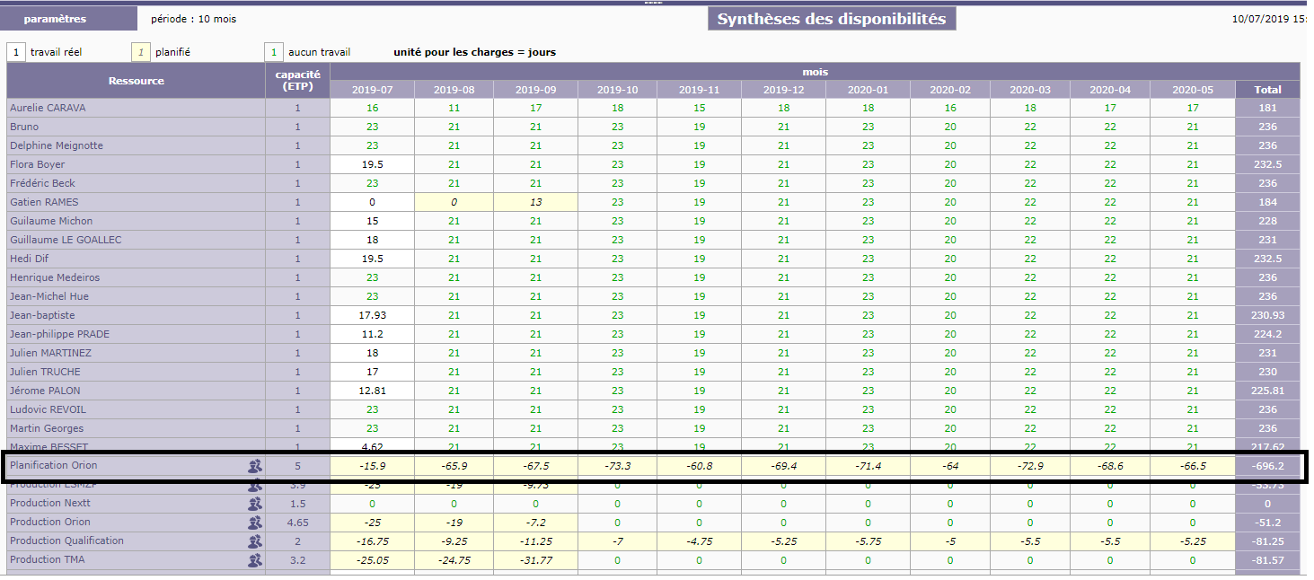
- why in summary of availabilities repport i have number of days planned and not number of days remaining planable (number of ETP * number of working day-number of days planned) (for sample for August 21*5-65,9) ?
Planning job for August:
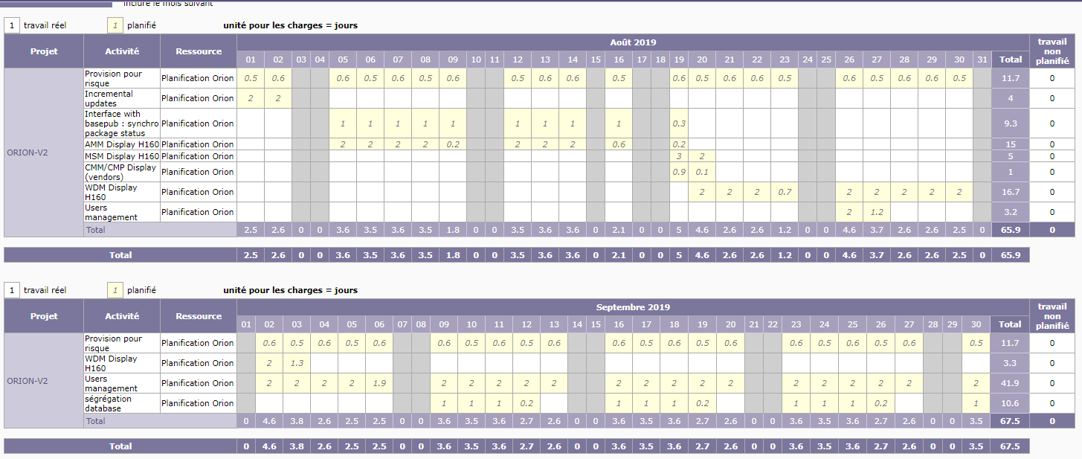
My gantt planning
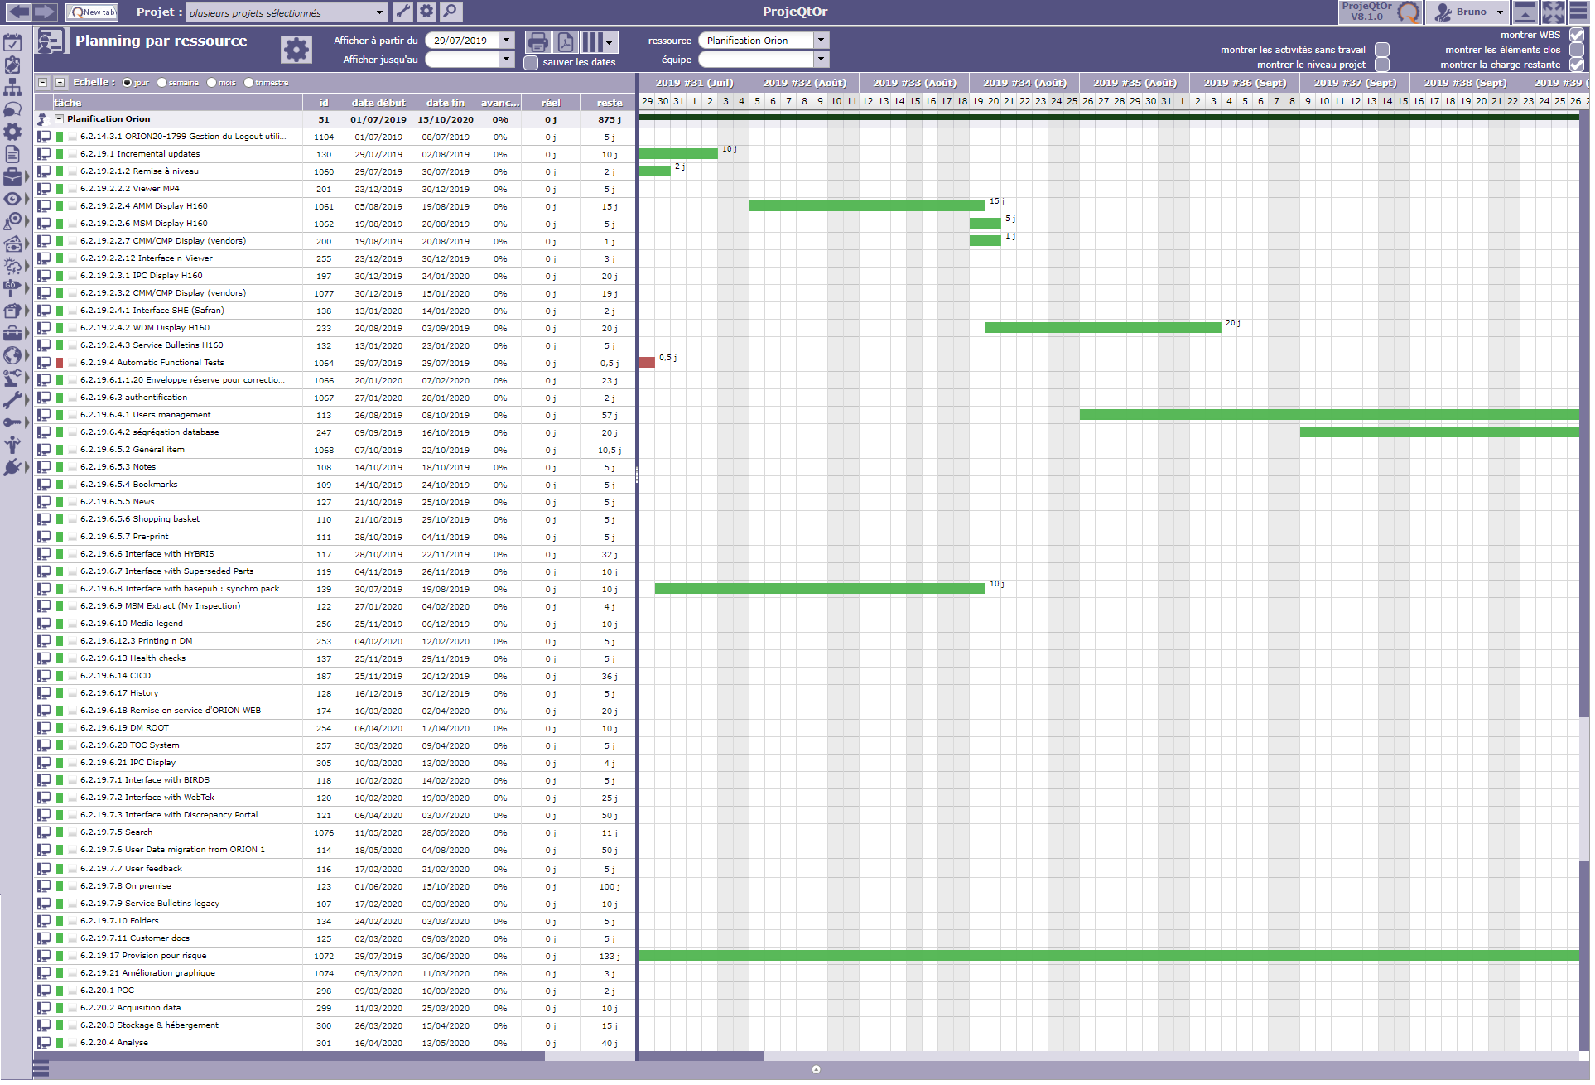
- Why for each days the full pool capacity are not planed ? (all task have no contraint (start date, dependance, ...) ?

