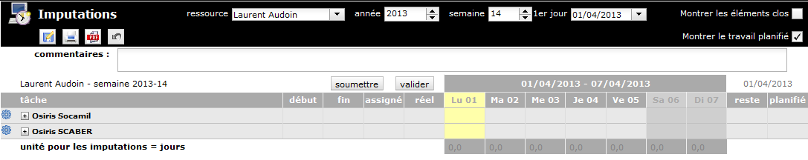
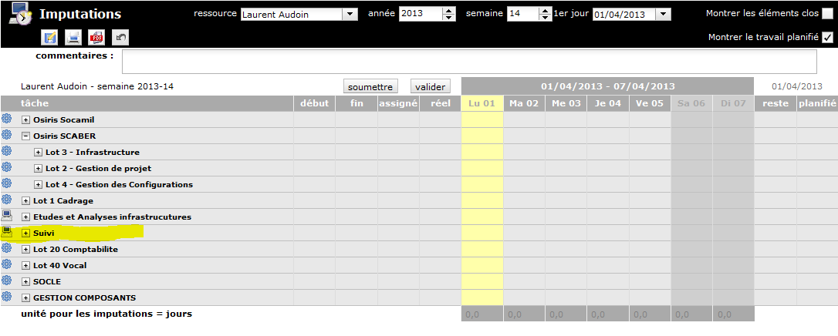
« Suivi » does not belong to « Osiris Scaber » but to OSILAND > Lot 3 Infrastructures OSILAND his project master and OSILAND > Lot 3 Infrastructures OSILAND is not show in this screen.
WBS :
27 OSILAND
27.10 Lot 3 Infrastructure OSILAND
27.10.4 Suvi
