This is a screen shot of the template project. It is in a proposed state, and has no existing real time charged.
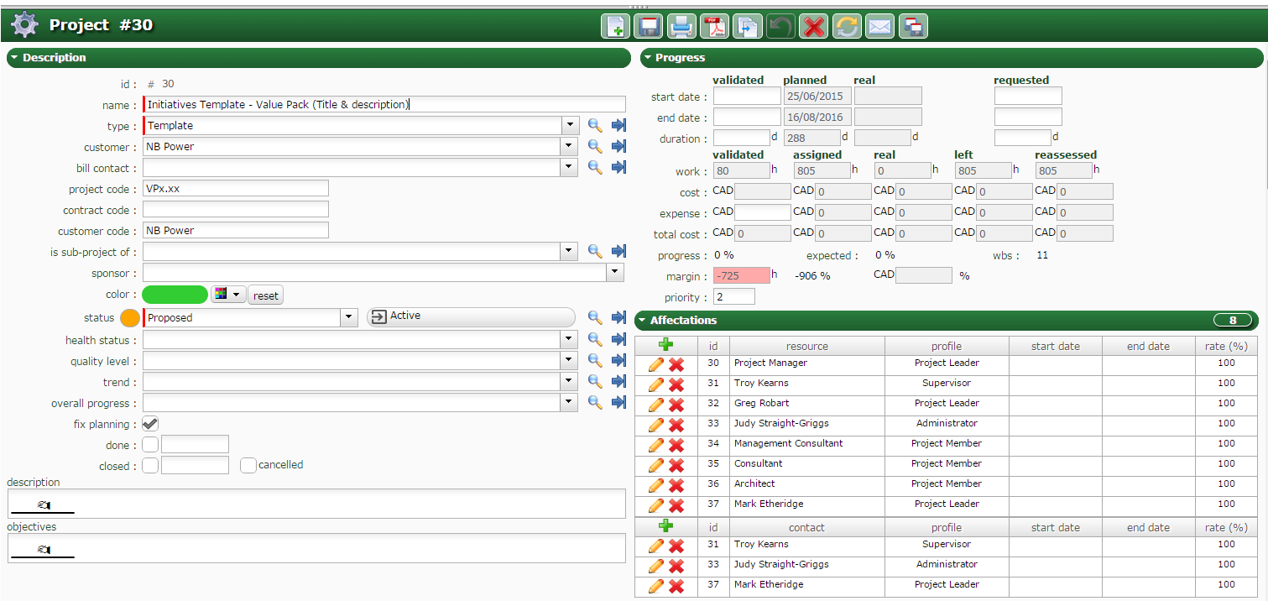
All activities are set to proposed, non are marked done:
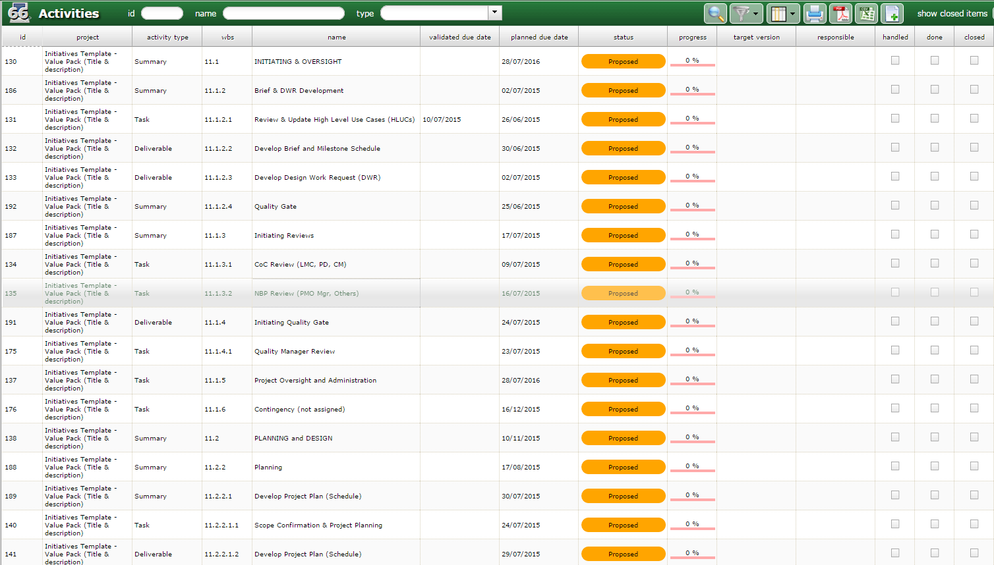

You can see from the planning view all the predecessors, summary tasks..etc are setup. Zero tasks have real hours
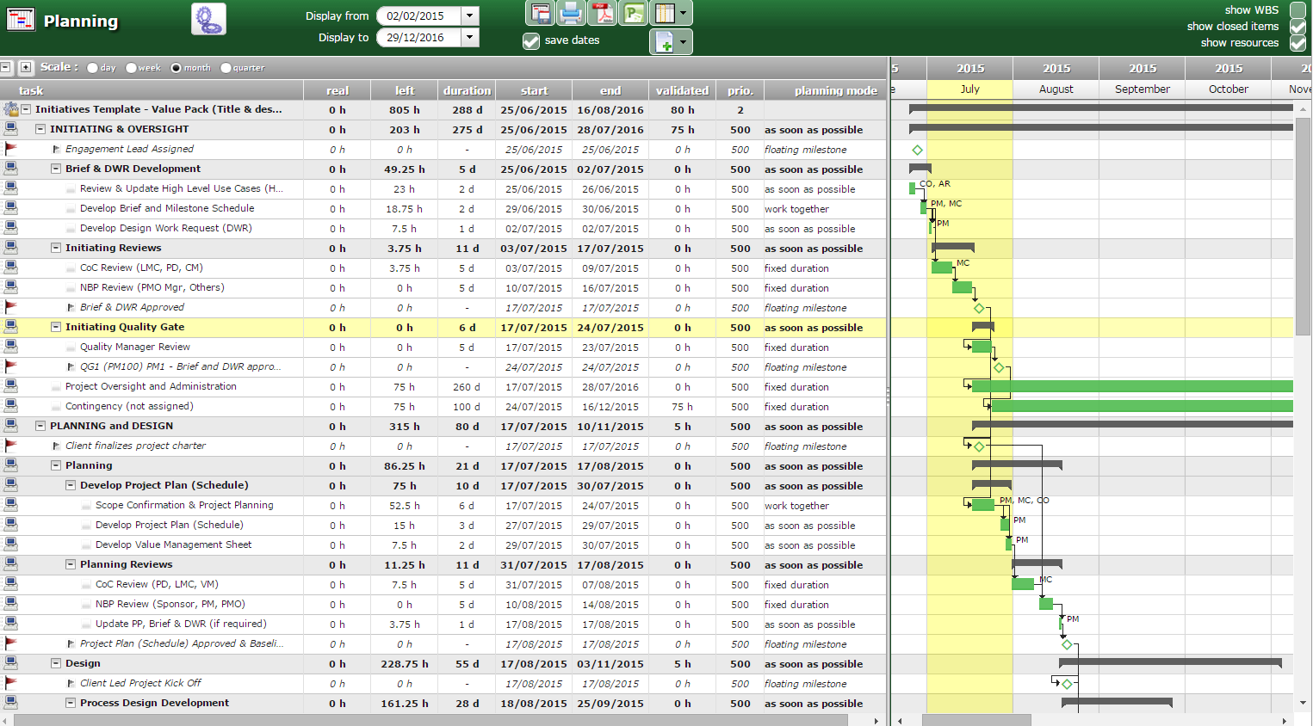

This is the project created from the template. There are no real hours, but there is a real start date, this occurred during the copy, not as a result of any real hours charged.
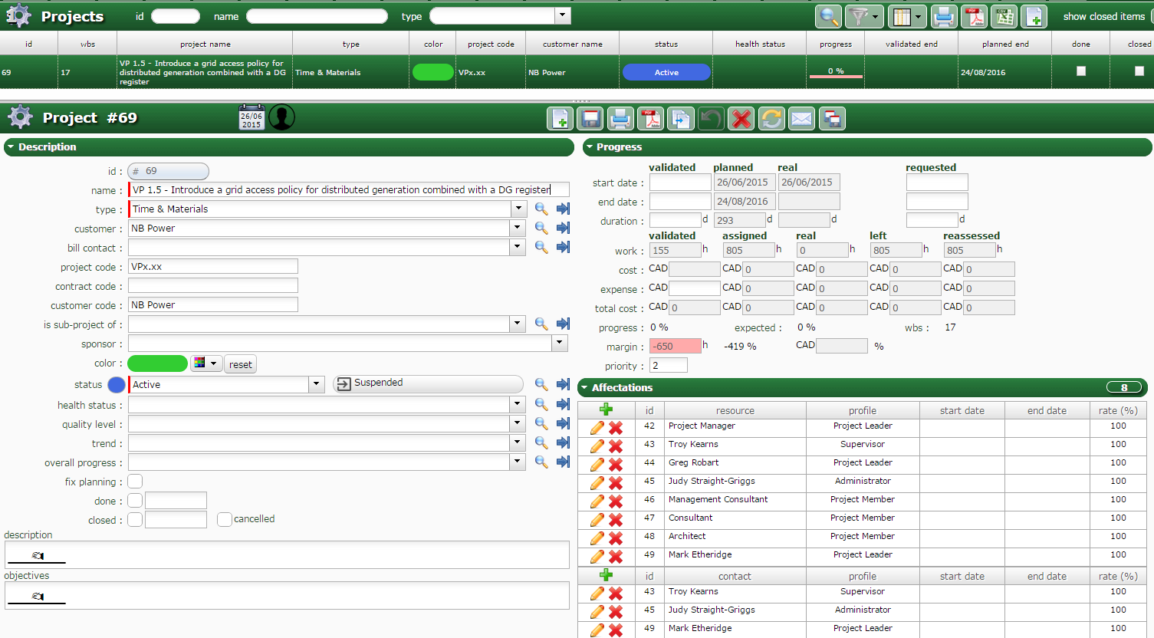

Many tasks have real start date, but no real work. Mostly Summary tasks, but not all.

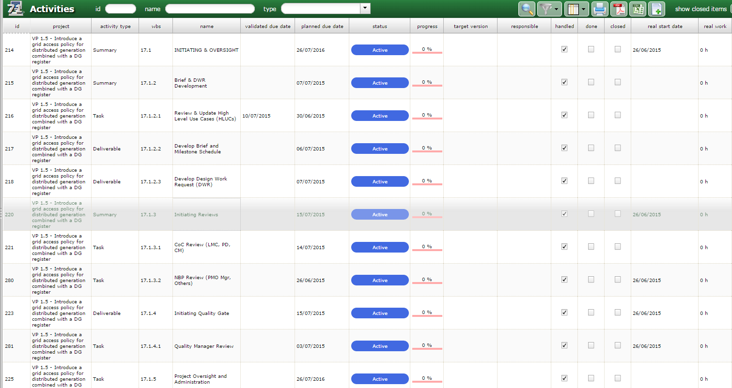
This has created out of sequence progress.
