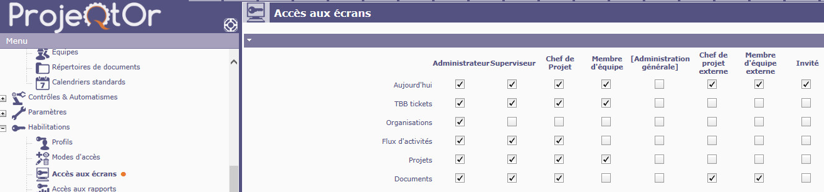

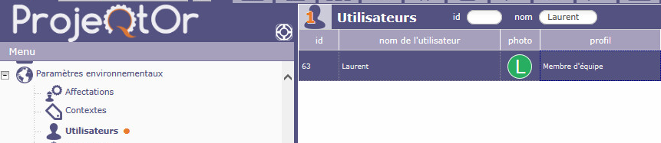

User Laurent
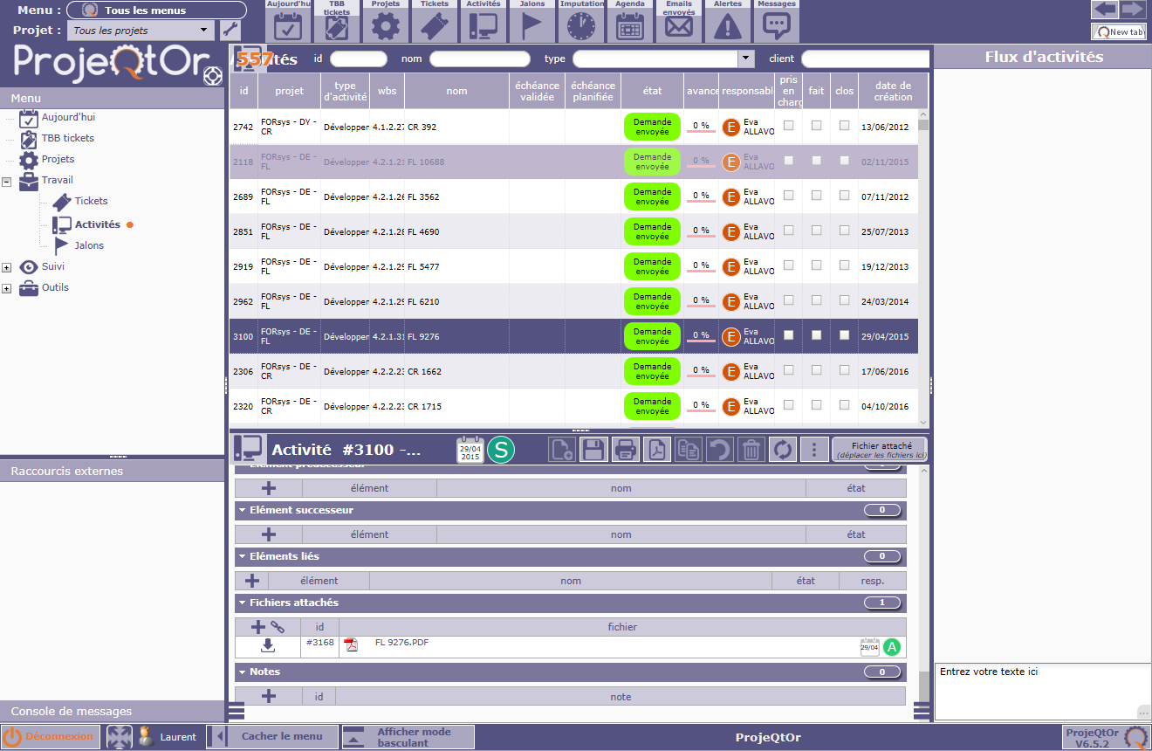
- Access to Activity Stream
- 0 Note

User Admin
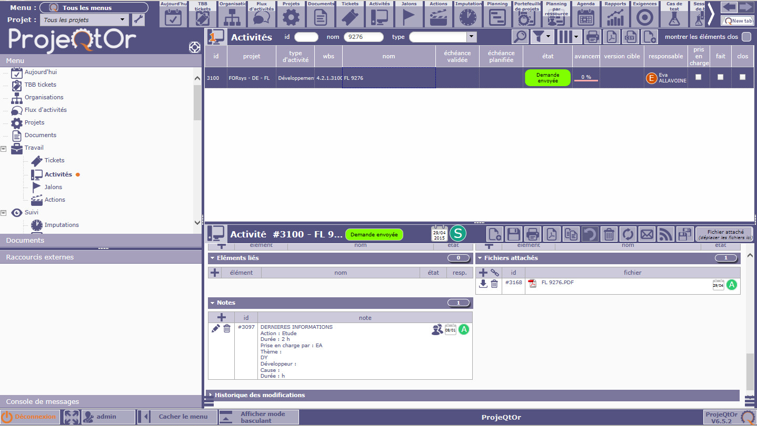
- 1 Note

