1. Click dispatch and delete dispatch work

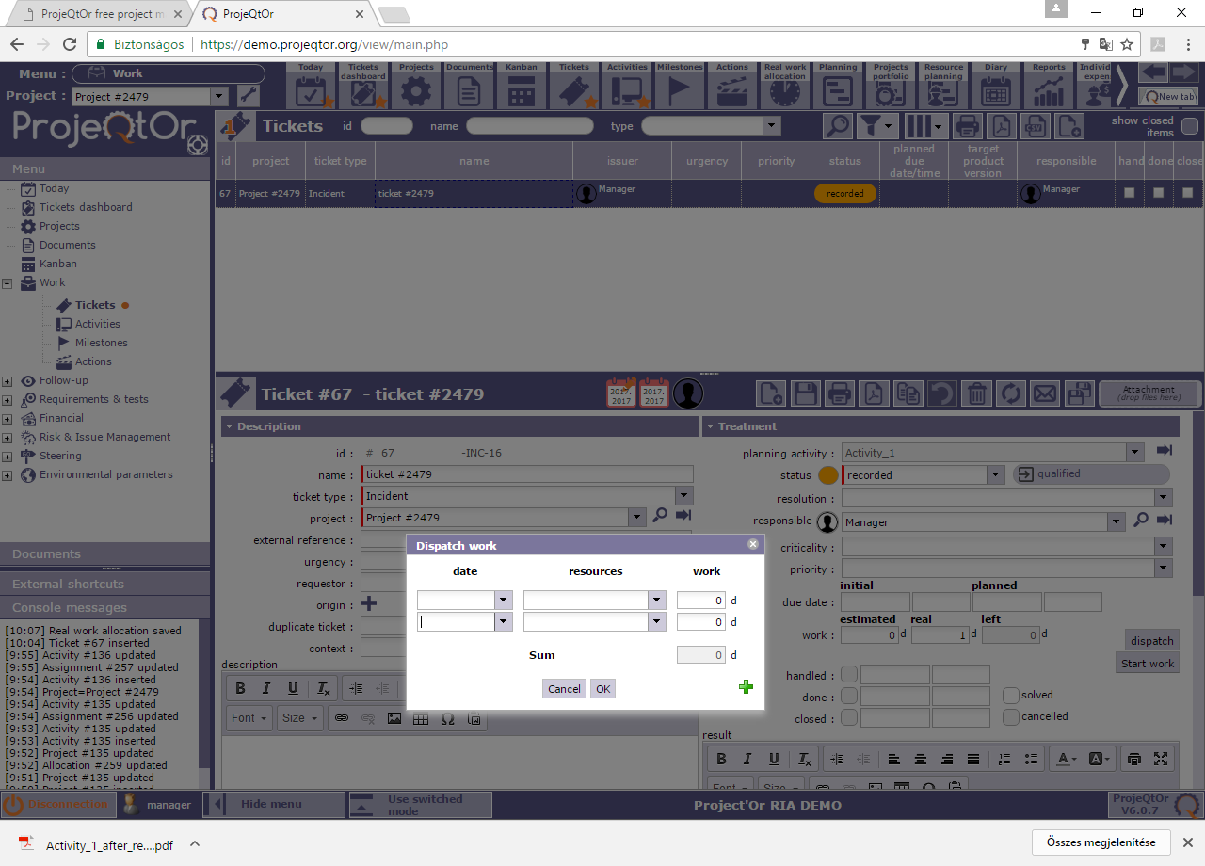

1. then click OK, can see that real work is 0 and activity is still not changeable

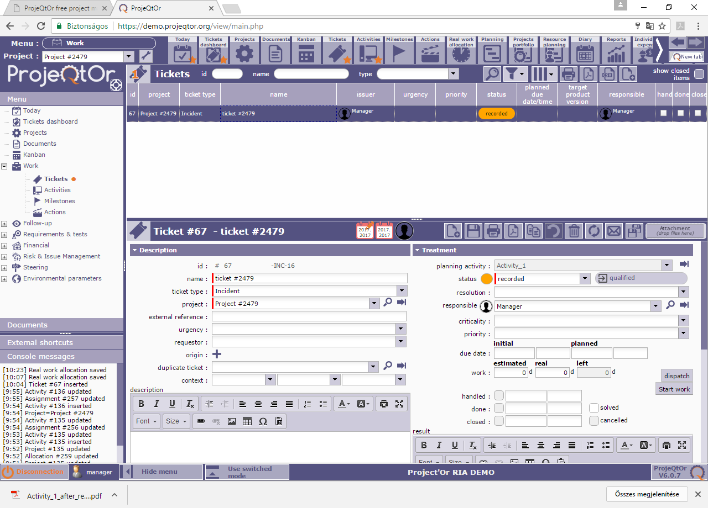

1. Refresh ticket list, now you can change planning activity

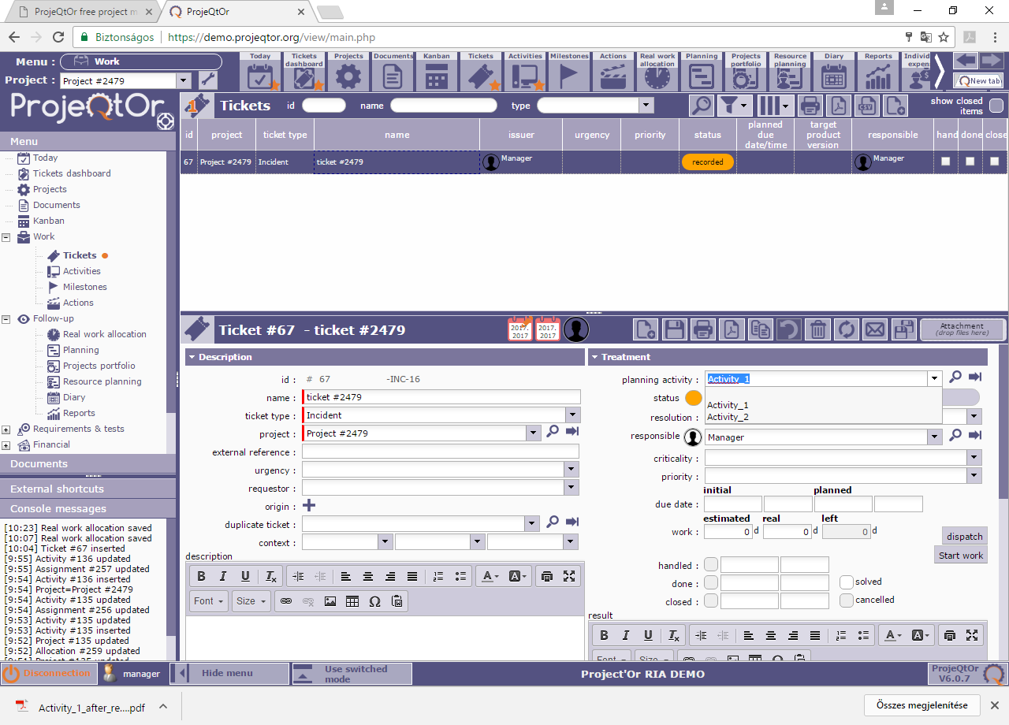

1. Choose activity_2 and save

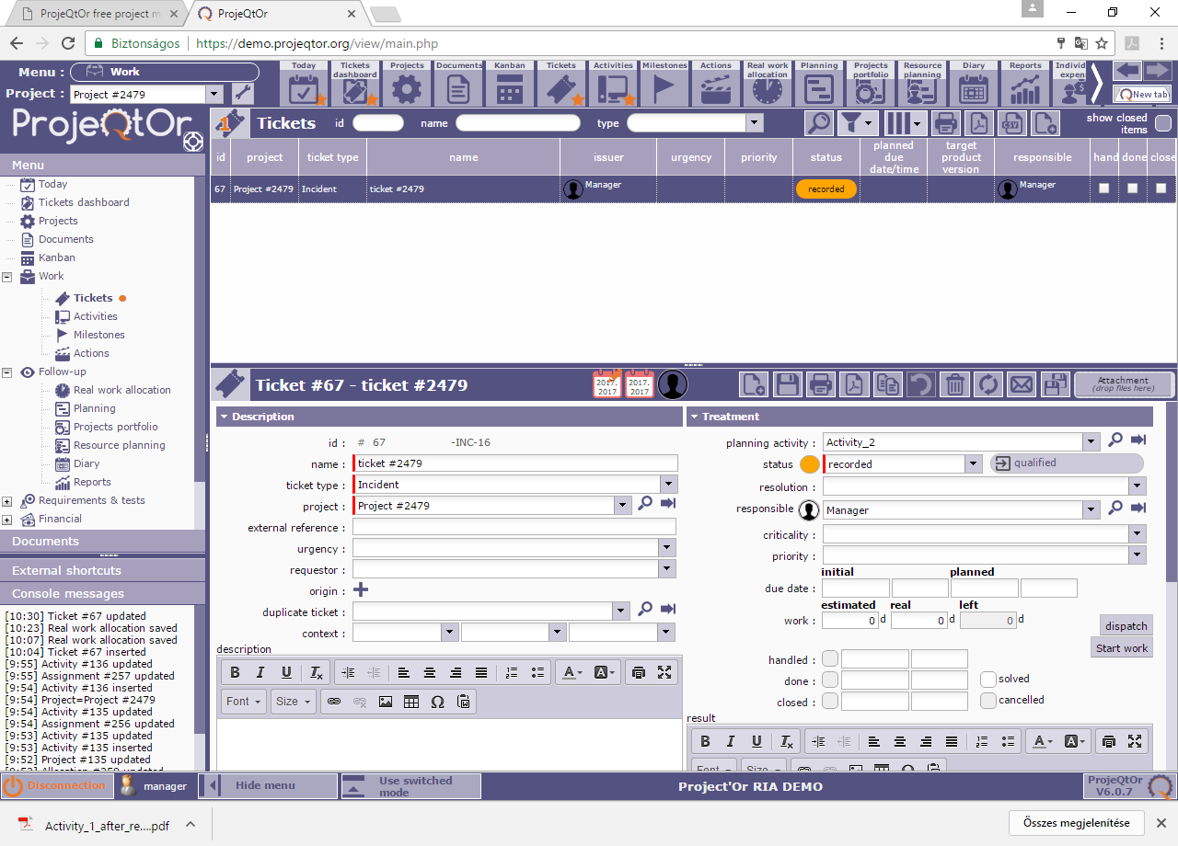

1. Click dispatch and put dispatch work and click OK

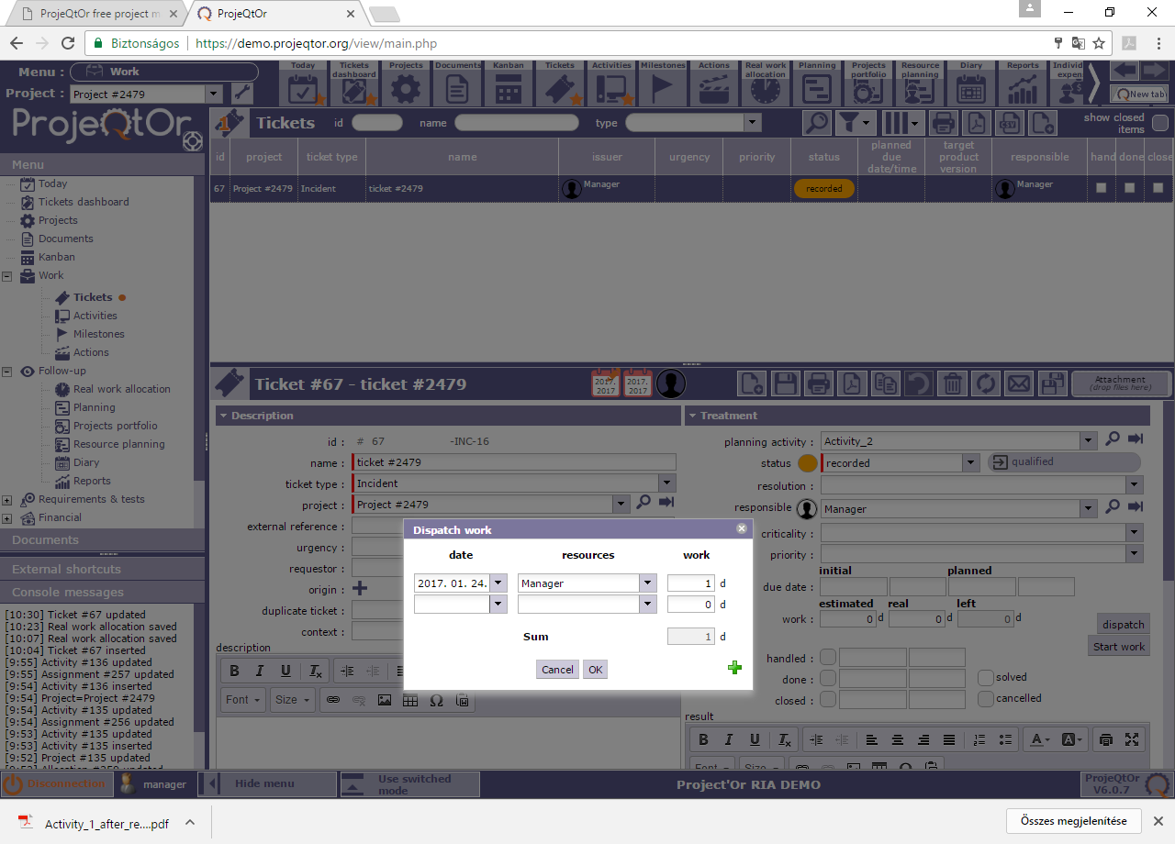

1. The ticket now shows Activity_2 with 1 day real work on.

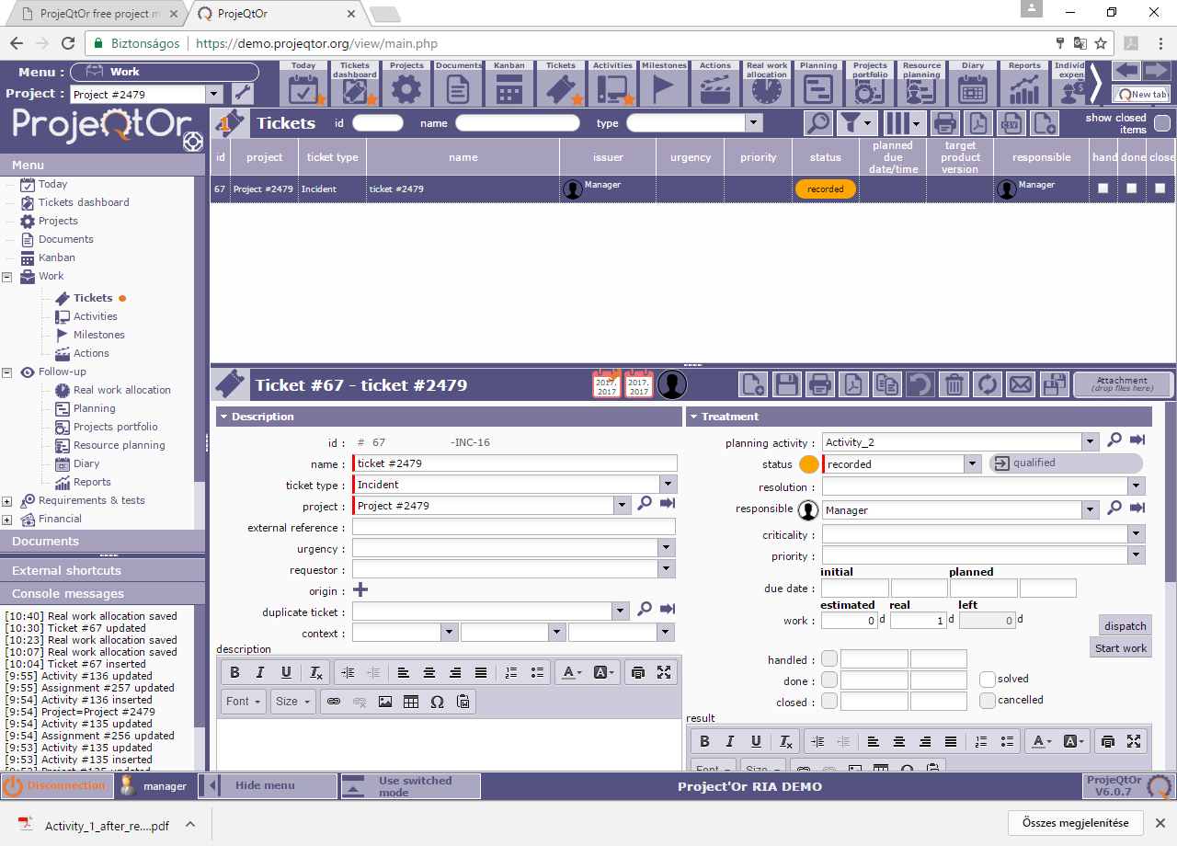

1. Go back to Activities:

Here on Activity_1 you can see 1day real work next to the validated work **(this is incorrect)** and 0 day real work on the ticket (this is correct).

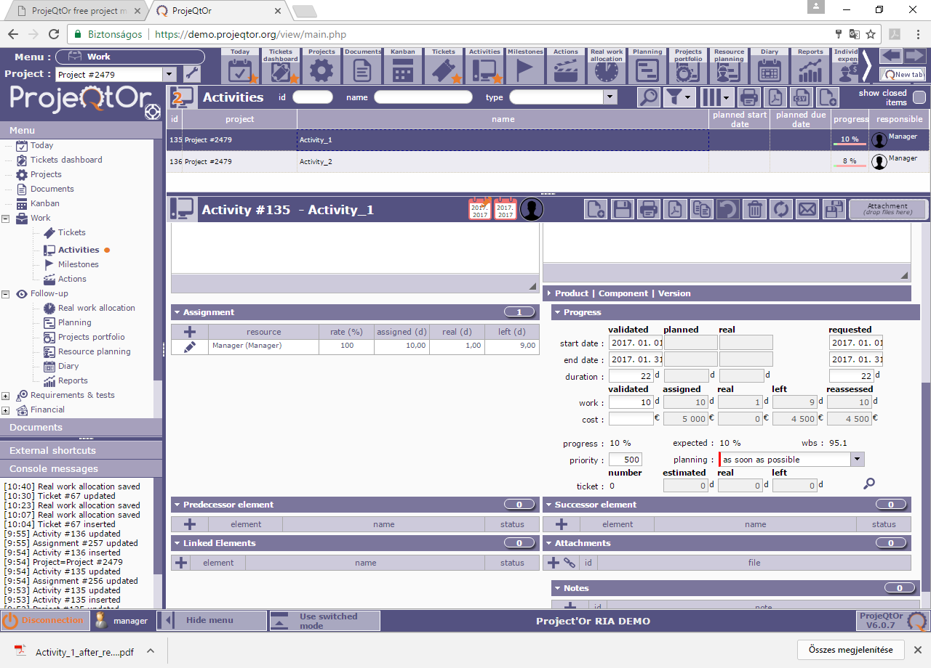

And on Activity_2 you can see 1 day real work next to the validated work (this is correct) and 1 day real work ont he ticket (this is correct)

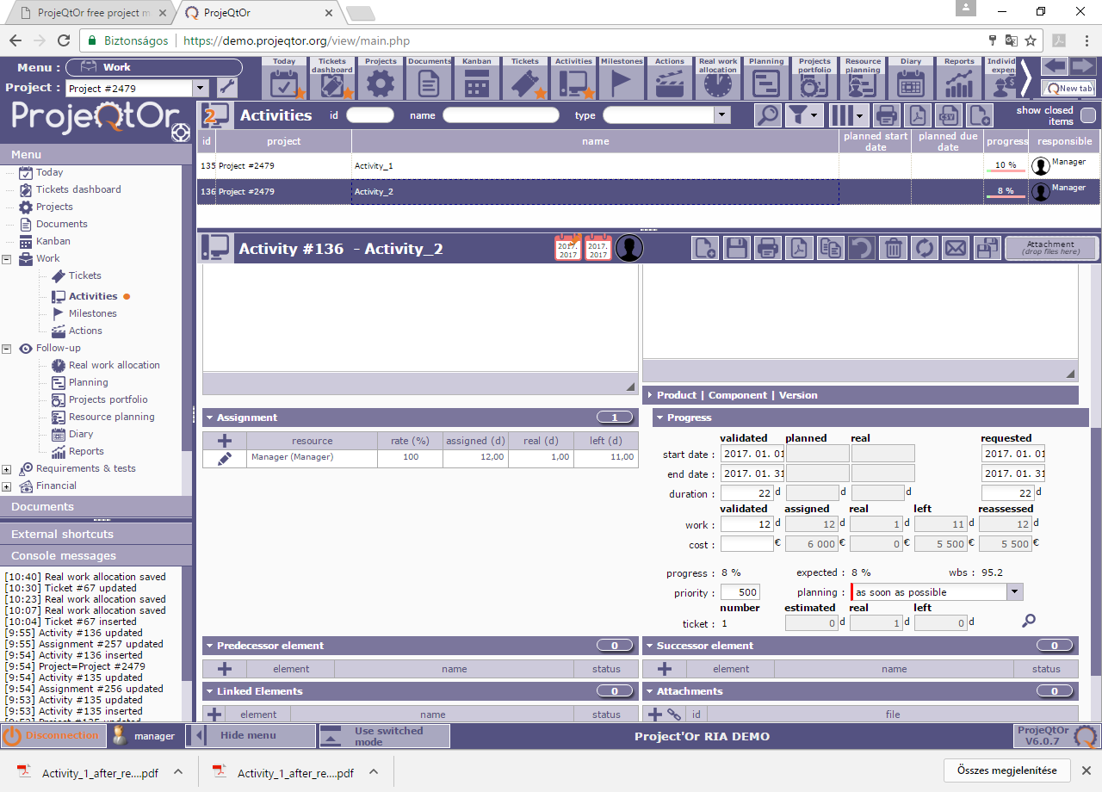

1. On this list you can see 1-1 day real work on both Activity, which is not correct.

The correct datas should be:

Activity_1: 0 day real work

Activity_2: 1 day real work

