Projeqtor version: >=7.3.3. ScreenCustomization plugin version V5.3
I want to customize 'Activity - Progress':
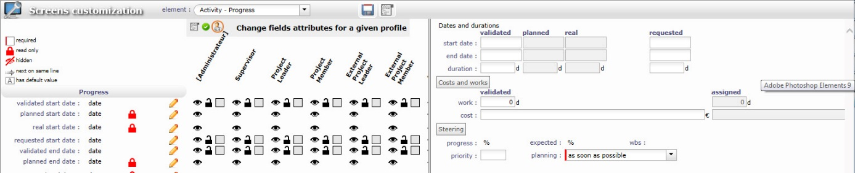

I want to change the color of the field ‘validated start date’ (where there is the red cross)
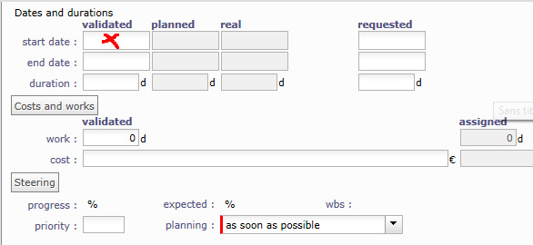
So I edit the field validated start date :
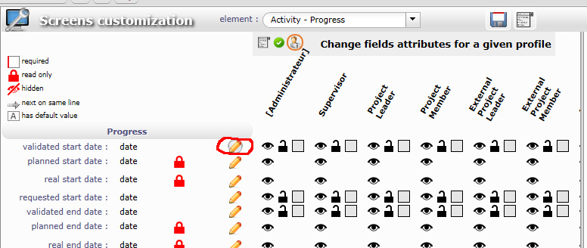
choose a color for the field :
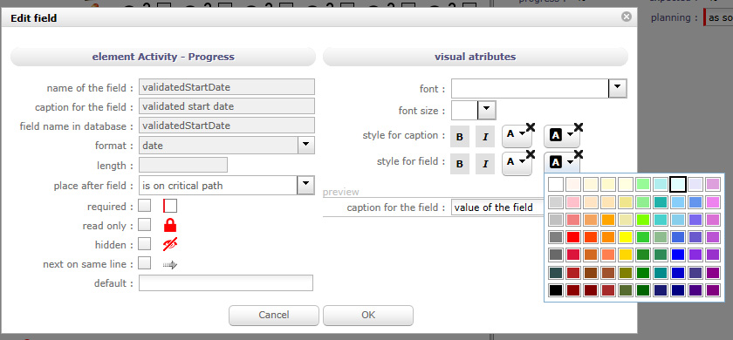
And press OK.
So I get :
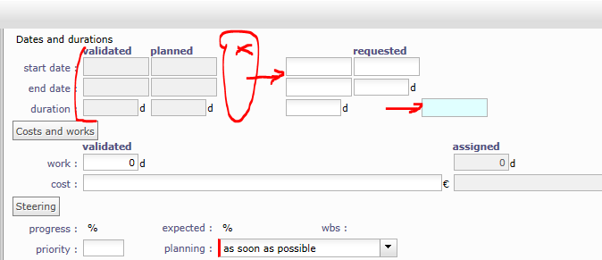
The validated data are read only, the real data moved and get editable, it is the requested duration field that has a new color.
And the validated start date has moved :
